Solar/Battery Power System

Clement Ong

Tarik Dawson

Lauren Lugo

Nathan Gil

**FINAL REPORT**

**Table of Contents**

Concept Of Operations…………………………………………………………..3

Functional System Requirements………………………………………………16

Interface Control Document…………………………………………………...34

Validation………………………………………………………………………...44

Schedule………………………………………………………………………….50

Subsystem Reports……………………………………………………………...44

MPPT Subsystem Report……………………………………………………………...46

DC - DC Converter……………………………………………………………………55

DC - AC Inverter………………………………………………………………………71

Website And Android Application……………………………………………………..83

System Description and Development...………………………………………..98

Solar/Battery Power System

Clement Ong

Tarik Dawson

Lauren Lugo

Nathan Gil

**Concept of Operations**

Final Draft

25th April 2023

Concept of Operations

for

Solar/Battery Power System

Team <16>

Approved by:

____Nathan Gil_______04/26/2023__

Project Leader Date

_____________________________

Prof. Kalafatis Date

______Dalton____________________

T/A Date

**Change Record**

| **Rev.** | **Date** | **Originator** | **Approvals** | **Description** |
| --- | --- | --- | --- | --- |
| **0** | September 15, 2022 | Pen-Hao Huang |  | Draft Release |
| **1** | October 2nd, 2022 | Pen-Hao Huang |  | Midterm Release |
| **2** | April 25th, 2023 | Pen-Hoa Huang |  | Final Release |

**Table of Contents**

**Table of Contents** **6**

**List of Tables** **7**

**List of Figures** **8**

[**1.** **Executive Summary**](https://docs.google.com/document/d/1oE2DfG66k3oLzQfO3jbMR8eg0nUGLV6A/edit#heading=h.1t3h5sf) **9**

**2.** **Introduction 9**

2.1. Background 10

2.2. Overview10

**3.** **Operating Concept 11**

3.1. Scope11

3.2. Operational Description and Constraints 11

3.3. System Description 12

3.4. Modes of Operations 13

3.5. Users 13

3.6. Support 13

**4.** **Scenario(s) 13**

[4.1. Charging Devices in Remote Locations](https://docs.google.com/document/d/1oE2DfG66k3oLzQfO3jbMR8eg0nUGLV6A/edit#heading=h.4i7ojhp) 13

4.2. Easier Access to Renewable Energy 14

4.3. Determining Optimal Solar Panel Positions 14

**5.** **Analysis 14**

5.1. Summary of Proposed Improvements 14

5.2. Disadvantages and Limitations 14

5.3. Alternatives 15

5.4. Impact 15

**List of Tables**

**List of Figures**

**Figure 1: Functional System Diagram………………………………………………………………….9**

**Figure 2: Topology of Solar Power Battery System……………………………………………..11**

# 

# Executive Summary

The purpose of this project is to provide easier access to generating clean energy for household devices without the need of multiple solar panels. The proposed solution is to create a functionally independent power grid capable of generating power from a solar cell system. This grid will be able to power both AC and DC consumer devices such as computers and smartphones while simultaneously charging a battery. Specifically, this will be done through Max Power Point Tracking (MPPT) to regulate the flow of voltage and current to optimize the system. Another key component will be the ability to switch to battery power in cases where the solar cells are not producing enough power. The user will be able to monitor this system and MPPT analysis using an android app and computer website.

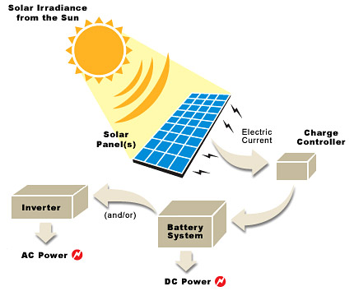

**Figure 1.** *Functional System Diagram*

# Introduction

As our world becomes more reliant on technology it is important to have sources of power to supply to our devices in a time of crisis. Texas more recently has experienced power outages during unexpected extreme winter conditions. Additionally, This system promotes the use of renewable energy which is rapidly becoming more popular in society. The solar/battery power system is a system built to convert solar power into usable DC or AC electricity that is capable of charging common electronic devices. This system will be able to switch between battery power and solar power to ensure constant power delivery, making the system work even when the sun is not present. The user of this device will be able to monitor the solar panel and battery outputs using a website and phone application. This device will be useful when electricity is not easily accessible.

## Background

The Earth’s temperature is steadily increasing, eventually making it too warm to grow crops, and increasing the risk of more frequent and heavier rainfall, snowfall, and other types of precipitation. A recent example of severe precipitation was the snowstorm in Texas on February 13th which caused 4.5 million homes to be without power, resulting in the worst energy infrastructure failure in history.

As a result, a need to switch from relying on fossil fuels to relying on renewable energy has emerged due to global warming and its effects. There are many types of renewable energy sources that are being used today to make the switch from fossil fuels. Harnessing energy from the sun, known as solar power, will be our focus for this project. Solar energy is one of the top three most popular renewable energy sources today since it is easy to install, predictable, requires little maintenance, and doesn't use power to operate.

Our team’s solar powered independent grid aims to showcase these advantages through solar energy’s reliability, effectiveness, and wide range of applications. This system will be able to monitor the sun for optimal power harnessing during peak sunlight hours and switch to battery power when interferences occur. With this architecture, the user will be able to charge their devices even when the sun is not out, providing cost effective alternatives to their current power sources.

## Overview

Our system will use a Maximum Power Point Tracking (MPPT) algorithm to continuously adjust the impedance seen by the solar array to keep the PV system operating at, or close to, the peak power point of the PV panel under varying conditions. This will optimize the power output of the solar panel so the battery can be charging while the user is charging their devices. If the PV panel is under varying conditions or there is no sunlight, the system will switch to battery power so the user’s devices will still receive power. Additionally, the algorithm will constantly send data to the backend database so that it can be stored and monitored using a website and android application. The purpose of the website and app is to funnel and display the data received from the solar panel such as a graph of the peak harnessing times throughout the day, the current power storage of the battery, maintenance of the solar panel, whether the battery is discharging or charging, and the current weather conditions.

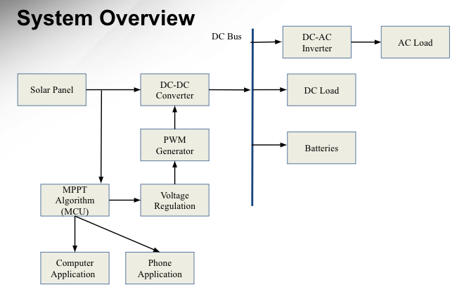

**Figure 2:** *Topology of Solar/Battery Power System*

# Operating Concept

## Scope

The solar/battery power system aims to provide a source of renewable energy, using solar energy to charge a laptop and a cell phone. The DC electricity generated by the solar panel flows through a DC-DC converter which acts to convert the variable input voltage (20-60 Vdc) to the desired output voltage (12 Vdc), while also charging a battery that will be used when not enough power is being produced by the solar panels. This ensures the charging of a device even when the sun is not present. A DC-AC inverter is used to convert the DC electricity (12Vdc) to AC electricity (115 Vac), allowing the use of the electrical grid. A MPPT algorithm will keep the PV system operating at the peak power point of the PV panel. The system will also constantly record and send data to the backend database, which will be displayed through a website and android app.

## Operational Description and Constraints

This power grid system is intended for consumers to store and generate consumer usable power, carrying the ability to use stored power in situations where adequate power is not generated from the solar panel. This data can be presented to the user through a website and app as stated above. Listed below are the constraints for this system.

* The budget for the solar/battery power system is $400.
* The system must be able to tolerate outdoor temperatures from -15 degC to 50 degC.
* Must be placed in light to generate power, stored power will only last so long.
* The solar/battery power system is not portable.
* The grid can only handle one load at a time.

## System Description

This solar power system will consist of four distinct subsystems; a max power point tracking system, a DC-DC converter, a DC-AC inverter, and a website/app. Detailed below is each subsystem and a short description of what they do and how they work.

* MPPT System - This subsystem regulates the power and voltage (PV) output between the solar panel and the battery. Specifically it will monitor the current and voltage output of the solar panel, battery, and DC-DC output. Additionally, this system will determine if the system will be supplied by the battery when the solar panel is not producing enough power.
* DC-DC Converter - This subsystem is dedicated to converting the input voltage to a desired output voltage. More specifically, the subsystem will draw altered voltage and current from the solar cells and decrease the voltage to 12V while increasing the current using a buck converter. Feedback will use the MPPT system to ensure a stable desired output voltage is achieved.
* DC-AC Inverter - The inverter acts to regulate the flow of electrical power. It switches the direction of direct current (DC) electricity back and forth very rapidly, converting it to alternating current (AC) electricity, and allowing an AC output identical to the United States power grid.
* Android Application and Website - This subsystem includes a backend database. This database will be created using google Firebase, which will also host the website. The android application and website will both use Ionic with angular, allowing for concurrent coding of the application and website. This subsystem will communicate with the ESP32 to receive data from the solar panel system. The data that is received and displayed includes the current and voltage from the solar panel and battery, the harnessing pattern from the sun in watts, if the system is in discharging or charging mode, the current weather in a city specified, and the power level of the battery.
* Switch Control - This subsystem will control when the system will draw power from the solar cell or the battery. If the solar cell is not delivering sufficient power, this controller will switch the system such that power will be directly drawn from the battery.

## Modes of Operations

This power grid system will have two main modes of operation. The first of which is when the solar panel itself is generating enough energy to power the consumer devices connected to it. In this case, the MPPT will regulate the voltage and current to charge the battery with max efficiency. The MPPT system will send a voltage to the DC-DC converter which will determine how much the current will increase or decrease to maintain a steady 12V supply. This 12V supply will be used directly on the 12V DC load or be converted to AC power through the inverter to the load when the battery is fully charged.Throughout this process, relevant voltage, current, and power data will be collected and sent to a database/website where it can be viewed by consumers.

The second mode of operation is if the solar panel does not provide enough energy to power the loads, typically at night or on cloudy days. In this case, power is taken directly from the battery storage (12V) and converted to either 115V 60 Hz AC for AC devices or directly used for DC consumer devices. The same current, voltage, and power data collection occurs in this mode of operation as well, funneling into an app and website viewable by consumers.

## Users

Our product is marketed primarily towards consumers that have a need to generate their own power independently, or simply want to start using renewable energy for means of a cleaner environment. The system is user friendly and requires little outside involvement as the system maintains itself. The user can set the device out to charge and generate power, then simply connect a device. Most small consumer devices will be compatible with the system including laptops and phones.

## Support

A detailed user manual will be included with the system, providing information on how the system works, instructions for installation and usage, tips for maintenance, tolerances, and additional relevant information regarding the product. The manual will also provide a website in which users can track the voltage, current, and power generated by the system.

# Scenario(s)

***4.1. Charging Devices in Remote Locations***

The primary use of a solar/battery power system is to have access to electricity when there is limited access to electricity. Due to the large size of this device it can be used in remote locations where someone is stationary for a long amount of time. This device can also track the amount of power and voltage available to them, and track when the solar panels reach maximum capability. The system allows someone to charge their phone and laptop at the same time during the day as well as during the night.

***4.2. Easier Access to Renewable Energy***

The solar/battery power system is useful in any location given enough room for the solar panels to fit. This allows a person to generate their own energy within their home and connect many common household devices (within the specified range). The solar panels allow the battery to charge during the day, thus allowing for the use of the devices even with the absence of sunlight.

***4.3 Determining optimal solar panel positions***

The solar/battery power system can be used to determine the best location for solar panels. Homes and businesses, who may not be familiar with the sun's positioning, can measure and track how much power the solar panels produce everyday. This data will be easily accessible through both applications to make the most efficient use of the solar panels.

# Analysis

## Summary of Proposed Improvements

* The battery will be solar powered. Therefore, it will be a self sustaining system.
* The system will supply both an AC and DC source, allowing for the charge of small electronics including laptops, phones, etc.
* The output will change depending on the amount of light received by the solar panels.
* The battery will be charged when light is received by the solar panel and supply power when light is no longer detected.
* The website will display the voltage output of the solar panel throughout the day for the user to track the efficiency.

## Disadvantages and Limitations

There are some limitations in the design of the solar/battery system. These are listed below:

* Due to the given price range, the overall power output of the solar panel will be the main priority. This directly decreases the ability to purchase a more efficient solar panel that can produce the same output while being smaller in design.
* System can only charge with sufficient light levels.
* Power generated during sufficient light level hours will depend on how big the solar cell is.
* Battery power will only be able to run for a couple of hours due to budget constraints
* The output terminals will only have two different types of outlets.

## Alternatives

The solar/battery power system has some alternatives solutions, some are listed below:

* The solar/battery power system could instead switch to battery when there is no light instead of sufficient light. The trade off being that the system could absorb more power than it is producing under low light levels.
* The solar panel can be switched out for any type of generator as long as the voltage and current are reconfigured.
* A smartphone application is an alternative to the website/database.

## Impact

There are economic, environmental, social, and health impacts associated with the solar/battery power system as listed below:

* **Economic Impact:** The system uses solar power, therefore it would lessen the cost of electrical bills.
* **Environmental and Sustainability:** The system uses a renewable energy source therefore decreasing the use of oil/gas methods.
* **Social:** Easier access to using renewable energy because of the lower cost of only supplying power to small devices. It will provide a good starting point for communities that may not be able to afford a solar panel array to power a house.
* **Health and Safety:** Producing power using the solar/battery power system is clean unlike most traditional generators. Owning and operating one of these systems will help battle pollution, a major health concern in this day and age.

Solar/Battery Power System

Clement Ong

Tarik Dawson

Lauren Lugo

Nathan Gil

**Functional System Requirements**

Final Draft

26th April 2023

Functional System Requirements

for

Solar/Battery Power System

Team <16>

Prepared by:

_____________________________

Author Date

Approved by:

____Nathan Gil_______04/26/2023__

Project Leader Date

_____________________________

John Lusher, P.E. Date

_____________________________

T/A Date

**Change Record**

| **Rev.** | **Date** | **Originator** | **Approvals** | **Description** |
| --- | --- | --- | --- | --- |
| **0** | October 2nd, 2022 | Pen-Hao Huang |  | Draft Release |
| **1** | December 4th, 2022 | Pen-Hao Huang |  | Midterm Release |
| **2** | April 25th, 2023 | Pen-Hao Huang |  | Final Release |

**Table of Contents**

**Table of Contents** 19

**List of Tables**21

[**List of Figures**](https://docs.google.com/document/d/1s3BxRQPUXpz8_8zUblvEg3eeZnPW3qNz/edit#heading=h.2et92p0) 22

**1.** **Introduction** 23

1.1. Purpose and Scope 23

1.2. Responsibility and Change Authority 24

**2.** **Applicable and Reference Documents** 24

2.1. Applicable Documents 24

2.2. Reference Documents 24

2.3. Order of Precedence 25

**3.** **Requirements** 25

3.1. System Definition 27

3.2. Characteristics 27

3.2.1. Functional / Performance Requirements 27

3.2.1.1. Solar Panel Maximum Power Output 27

3.2.1.2. Range of Loads 27

3.2.1.3 Switch Check 28

3.2.1.4 AC output 28

3.2.1.5 Max Power Point Tracing 28

3.2.1.5 System Shut Off 28

3.2.2. Physical Characteristics 28

3.2.2.1. Mass 28

3.2.3. Electrical Characteristics 28

3.2.3.1. Inputs 28

3.2.3.1.1 Power Consumption 28

3.2.3.1.2 Input Voltage Level 29

3.2.3.1.3 Wifi Communication 29

3.2.3.2. Outputs 29

3.2.3.2.1 Data Output 29

3.2.3.2.2 Diagnostic Output 29

3.2.4. Environmental Requirements 29

3.2.4.1. Pressure (Altitude) 29

3.2.4.2. Thermal 30

3.2.4.5. Humidity 30

3.2.5. Website and Application Requirements 30

3.2.5.1. Website and Application Pull Request 30

3.2.5.2 Back-end from ESP-32 Communication 30

3.2.5.3 Front-End From ESP32 Communication 30

3.2.5.4 Physical Requirements 30

3.2.5.5 User Authentication 31

3.2.5.6 Existing User Authentication 31

3.2.6. DC-DC Converter Requirements 31

3.2.6.1 DC-DC Converter Feedback 31

3.2.6.2 DC-DC Converter Load Current Validation 31

3.2.6.3 DC-DC Converter Input Range Validation 31

3.2.6.4 DC-DC Converter Efficiency Validation 31

3.2.7. Full-Team Testing 31

3.2.7.1 Safety System Shut Down 31

3.2.7.2 Through Power (Solar Panel) 32

3.2.7.3 Through Power (Battery) 32

3.2.7.4 Full System Test (Solar Panel) 32

3.2.7.5 Full System Test (Battery) 32

**4.** **Support Requirements** 32

4.1. Computer or Smartphone with Internet Access 32

4.2. Local Wifi Access 33

4.3. Maintenance 33

**Appendix A Acronyms and Abbreviations** **33**

**Appendix B Definition of Terms** **33**

**List of Tables**

**Table 1: Subsystem Leads…..…………………………….……………………………………………….24**

**List of Figures**

**Figure 1: Topology of Solar Power Battery System……………………………………………..23**

**Figure 2: Block Diagram of System…………………………………………………………………….26**

# Introduction

## Purpose and Scope

The solar/power battery system is an accessible way to bring clean energy into homes. It can be used during power outages or for those living in rural areas. The design is to help those with basic knowledge of solar panels regulate and sustain their independent grid. The system will be able to charge common household electronics including laptops and phones. The user will be able to oversee the grid using an android phone application and a computer website. **Figure 1** below represents the system overview of the project in the proposed CONOPS document.



**Figure 1.** *Topology of Solar Power Battery System*

The system will be powered by solar power during the day, and then by a battery when the sun is no longer sufficiently providing energy. Current and voltage sensors will record the output of the solar panels, battery, and DC load. The Maximum Power Point Tracking (MPPT) will determine the optimal voltage and current to be set throughout the system based on the efficiency of the solar panel. All of the information collected will be transmitted through WiFi, which will then be uploaded to an online database. The system will display the trends and information of the day and present it on an android phone application and computer website.

## Responsibility and Change Authority

The team leader, Nathan Gil, has the responsibility of making sure that all requirements for the project are met. These requirements can only be changed through the approval of the team leader, and the approval of the sponsor Dr. Peng-Hao Huang.

| **Subsystem** | **Responsibility** |
| --- | --- |
| Microcontroller and MPPT | Lauren Lugo |
| DC to DC Converter | Tarik Dawson |
| DC to AC Inverter | Clement Ong |
| Phone and Computer Application | Nathan Gil |

***Table 1.*** *Subsystem Leads*

# Applicable and Reference Documents

## Applicable Documents

The following documents, of the exact issue and revision shown, form a part of this specification to the extent specified herein:

| **Document Number** | **Revision/Release Date** | **Document Title** |
| --- | --- | --- |
| IEEE 307 | 1969 | IEEE Standard Definitions of Terms for Solar Cells |
| C2-2023 | 2023 | National Electrical Safety Code (R) |

## Reference Documents

The following documents are reference documents utilized in the development of this specification. These documents do not form a part of this specification and are not controlled by their reference herein.

| **Document Title** | **Publisher** |
| --- | --- |
| ESP32 WROOM Data Sheet | Espressif Systems |

## Order of Precedence

In the event of a conflict between the text of this specification and an applicable document cited herein, the text of this specification takes precedence without any exceptions.

All specifications, standards, exhibits, drawings or other documents that are invoked as “applicable” in this specification are incorporated as cited. All documents that are referred to within an applicable report are considered to be for guidance and information only, except ICDs that have their relevant documents considered to be incorporated as cited.

# Requirements

When we refer to the “Microcontroller and MPPT system” we are referring to a subsystem that is composed of a microcontroller, sensors, switches and the MPPT algorithm. This subsystem will monitor and regulate the outputs of the solar panel, DC-DC converter, and the battery. In doing so, the subsystem shall be able to determine if the solar panel should be in charging or discharging mode and the current and voltage of the solar panel after harnessing power from the sun. This subsystem shall then be able to send this data to the website and android application through a backend database. The “website and android application” refers to the user interface that the user will see when trying to evaluate the solar powered system. This system shall be able to retrieve data from the database and display it for the user for their convenience and analysis. The website will be accessible for anyone from anywhere as long as it has been paired up with their specific solar powered system. The android app shall operate in a timely manner for android users and display the information provided under the **Block Diagram of System** section. The “DC to DC converter” shall be able to convert 20V to 60V from the solar panel to 12V which can be used anywhere else in the system. This subsystem shall work accurately and accordingly to not harm a user's device. The “DC to AC inverter” is composed of an AC inverter and a PWM generator which shall alter the DC output of the solar panel into the appropriate AC signal needed for the AC output.

## System Definition

The solar/battery power system aims to provide a source of renewable energy, using solar energy to provide power to a laptop, cell phone, and various other consumer devices. The system will charge a battery while also providing an AC outlet as well as DC outlet to power any device connected to it. The solar/battery power system consists of 4 subsystems as shown in the figures below: Microcontroller and MPPT, DC-DC converter, DC-AC inverter, and the android and computer application.

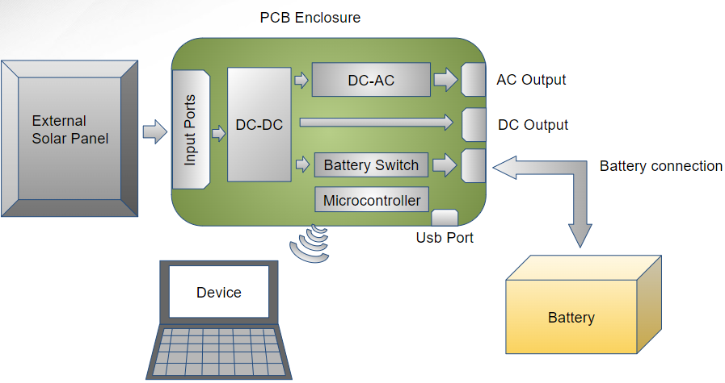

***Figure 2.*** *Block Diagram of System*

The microcontroller/MPPT subsystem shall use current and voltage sensors to determine the best way to regulate the system by decreasing or increasing the current. Specifically, it will send an adjusted voltage signal to the DC-DC converter to output a corrected voltage and current. This will be done through the microcontroller which shall use Maximum Power Point Tracking (MPPT) to optimize the output to the loads. Additionally, this subsystem will use the microcontroller to determine which switches should be opened and closed. For example, when the solar panel is not producing enough power the solar panel switch shall open and we shall check if the battery is charged and close the switch between the load and the battery. All data from the sensors shall be sent over wifi to the database used for the android application and website subsystem.

The DC-DC buck converter subsystem shall take the variable output voltage of the solar panel from 20V to 60V and convert it to a stable 12VDC for use directly, or in other systems. The result of this allows the buck converter to output 12V no matter the input voltage (no matter the time of day) The output voltage can be changed by increasing the feedback voltage coming from the MPPT system. Increasing this voltage will cause the output voltage to lower and thereby allowing the MPPT to control the output of the system. In the case that the solar panel provides less than 12V, the microcontroller shall switch the system to use battery power. Both the input and output of this subsystem is monitored via the voltage/current sensors, which in turn, feed back into the microcontroller to be displayed through the application.

The DC-AC inverter subsystem will take in 12VDC from the DC-DC converter subsystem, convert it into 12VAC, then step up with a transformer, producing an AC output identical to the U.S. electrical grid. It will be made up of an MCU that will produce PWM, an H-bridge, a step-up transformer, and other basic elements used in electronic circuits. A voltage and current sensor will monitor the output of the inverter for the purpose of data collection which will be displayed through the user interface application.

Android Application and Website will both use Firebase as a backend database to organize and fetch data that is received from the ESP32. Both applications shall consist of a user authentication page to provide security for user data, both applications, and database. This authentication shall consist of password, username, existing user, and new user checking. Once logged in, the data displayed consist of the power harnessed from the sun for that specific day, the max power output for a given day, the current, voltage, and power from inside the system, whether or not the system is charging devices using solar power or battery power, the battery level, and the current weather in a city provided by the user. There shall be data on a weekly basis consisting of power, current, and voltage for the solar battery system as well. Both of these applications will be created using Ionic with Angular. These two softwares allows the user to create an app and website concurrently.

Overall, the system gathers energy from the solar panel, then either stores it in a battery or powers the consumer electronics connected to it. Every node will be tracked and delivered to the Phone and Computer application where it can be viewed for either maintenance or leisure purposes.

## Characteristics

### Functional / Performance Requirements

#### **Solar Panel Maximum Power Output**

The Solar/Battery Power System shall function as intended on any and all solar panels that provide up to 260W max power output.

*Rationale: The Solar/battery power system was designed to operate using a 260W max power solar panel. Any solar panel that provides equal to or less than 260W shall be able to work with the Solar/battery power system.*

#### **Range of Loads**

The Solar/Battery Power System shall be able to power all consumer electronics that consume up to 8W either in DC or in AC.

*Rationale: This is a requirement specified by our customer due to constraints of their system in which the Solar/battery power system is integrating.*

### Switch Check

The Solar/Battery Power System shall switch to battery power if the solar panel is not producing enough power.

*Rationale: This is a requirement specified by our customer due to constraints of their system in which the Solar/battery power system is integrating.*

### AC Output

The Solar/Battery Power System shall output AC electricity that is identical to the United States power grid.

*Rationale: This is a requirement specified by our customer due to constraints of their system in which the Solar/battery power system is integrating.*

### Max Power Point Tracing

The Solar/Battery Power System shall be able to trace the maximum power point.

*Rationale: This is a requirement specified by our customer due to constraints of their system in which the Solar/battery power system is integrating.*

* + - 1. **System Shut Off**

The Solar/Battery Power System shall disconnect when not enough power is being supplied.

*Rationale: This is a requirement that ensures the safety of the system.*

### Physical Characteristics

#### **Mass**

The mass of the Solar/Battery Power System shall be less than or equal to 32 kilograms.

### Electrical Characteristics

#### **Inputs**

1. The presence or absence of any combination of the input signals in accordance with ICD specifications applied in any sequence shall not damage the Solar/Battery Power System, reduce its life expectancy, or cause any malfunction, either when the unit is powered or when it is not.
2. No sequence of command shall damage the Solar/Battery Power System, reduce its life expectancy, or cause any malfunction.

*Rationale: By design, shall limit the chance of damage or malfunction by user/technician error.*

##### Power Consumption

The maximum peak power of the system shall not exceed 260 watts.

*Rationale: This is a requirement specified by our customer due to constraints of their system in which the Solar/Battery Power System is integrating.*

##### Input Voltage Level

The input voltage level for the Solar/Battery Power System generated from the solar panels shall be +0 VDC to +60 VDC.

*Rationale: This is a requirement specified by our customer due to constraints of their system in which the Solar/battery power system is integrating.*

##### Wifi Communication

The ESP32 will send voltage and current data over the wifi to the firebase backend and then the front-end angular application in which data will be displayed.

*Rationale: This is a requirement specified by our customer due to constraints of their system in which the Solar/battery power system is integrating.*

#### **Outputs**

##### Data Output

The Solar/Battery Power System shall include a website and an android application for users to view information and trends regarding the system.

*Rationale: The Solar/Battery Power information passes directly to the customer’s system.*

##### Diagnostic Output

The Solar/Battery Power System shall include a diagnostic interface for maintenance and data logging.

*Rationale: Provides the ability to control things for debugging manually and a way to view/download the node map with associated potential targets.*

### Environmental Requirements

The Solar/Battery Power System shall be designed to withstand and operate in the environments and laboratory tests specified in the following section.

*Rationale: This is a requirement specified by our customer due to constraints of their system in which the Solar/Battery Power System is integrating.*

#### **Thermal**

The Solar/Battery Power System shall be able to tolerate outdoor temperatures ranging from -15 °C to 50 °C.

*Rationale: The minimum temperature in Bryan, Texas can reach -5 °C and the maximum temperature can reach 40 °C.*

#### **Humidity**

The Solar/Battery Power System shall be able to function properly in an environment with humidity levels ranging from 0% to 100%.

*Rationale: This is a requirement specified by our customer due to constraints of their system in which the Search and Rescue System is integrating.*

### Website and Android Application Requirements

#### **Website and Application Pull Request**

The website and application shall successfully pull data from the firebase database without interruption.

*Rationale: In order to display data on the website and android application dynamically, they both shall pull data successfully to be displayed.*

#### **Back-End from ESP-32 Communication**

The firebase database shall successfully receive data from the ESP-32 without interruption.

*Rationale: In order to display data on the website and android application dynamically, they both shall pull data successfully to be displayed.*

#### **Front-End from ESP-32 Communication**

The website and android application shall receive data from the backend firebase database which received its data from the ESP32 successfully.

*Rationale: In order to display data on the website and android application dynamically, they both shall pull data successfully to be displayed.*

#### **Physical Requirements**

The website and application shall be displayed properly on an android display and shall be functional in all aspects as listed by the sponsor.

*Rationale: This is a requirement specified by our customer due to constraints of their system in which the Solar/Battery Power System is integrating.*

#### **User Authentication**

The website and application shall allow the user to create a new account as long as the password exceeds six characters, the email is a valid email address, and there is not a user with the same username as the one that is being created.

*Rationale: This is a requirement so only users that have been authenticated can receive and write data to the backend database.*

#### **Existing User Authentication**

The website and application shall check if there is a user that exist with the email used to sign-in and if the password is correct

*Rationale: This is a requirement so only users that have been authenticated can receive and write data to the backend database.*

**3.2.6 DC-DC converter Requirements**

The DC-DC converter shall convert 20V-60V variable DC input into 12V DC output

*Rationale: The subsystem must be able to reliably power the other systems*

**3.2.6.1 DC-DC converter Feedback validation**

The DC-DC converter shall have a feedback network such that the MPPT system can control or lower the output voltage.

*Rationale: In order to charge a battery, voltage will need to be able to be changed.*

**3.2.6.2 DC-DC Converter Load Current Validation**

The DC-DC converter shall have the ability to supply 0 amps up to 20 amps as the rest of the system.

*Rationale: In order to power multiple 100W devices, at least 200 watts are required. Ensuring 20 amps can be supplied will cover up to 240 watts consumed.*

**3.2.6.3 DC-DC Input Range Validation**

The DC-DC converter shall function as intended with input ranging from 20V DC to 60V DC.

*Rationale: The input is a solar panel whose output is 0V to 60V*

**3.2.6.4 DC-DC Converter Efficiency Validation**

The DC-DC converter shall be at the least above 60%

*Rationale: Converter must be able to transfer power efficiently*

**3.2.7 Full Team Testing**

**3.2.7.1 Safety System Shut Down**

The system shall shut down when there is not enough power supplied.

*Rationale: System protection is needed so that the battery is not damaged or system does not function properly*

**3.2.7.2 Through Power (Solar Panel)**

Power flows from the battery all the way to both outputs under load.

*Rationale: This is a requirement specified by our customer due to constraints of their system in which the Solar/Battery Power System is integrating*

**3.2.7.3 Through Power (Battery)**

Power flows from the battery all the way to both outputs under load.

*Rationale: This is a requirement specified by our customer due to constraints of their system in which the Solar/Battery Power System is integrating.*

**3.2.7.4 Full System Test (Solar Panel)**

System powers AC and DC loads via solar panel while providing data to the ESP-32 which sends it to the backend database.

*Rationale: This is a requirement specified by our customer due to constraints of their system in which the Solar/Battery Power System is integrating.*

**3.2.7.5 Full System Test (Battery)**

System powers AC and DC loads via battery while providing data to the ESP-32 which sends it to the backend database.

*Rationale: This is a requirement specified by our customer due to constraints of their system in which the Solar/Battery Power System is integrating.*

# Support Requirements

#### **Computer or Smartphone with Internet Access**

The website will be hosted using firebase, which has to be accessed through the internet. The app can only be downloaded and connected with internet access. To view the data that is displayed on the website and android application, the user must meet this requirement.

*Rationale: Other forms of accessibility to this system are outside the scope of this project.*

#### **Local Wifi Access**

In order to view the data from the system, the system needs to have access to WiFi so that the ESP32 can communicate with the backend database.

*Rationale: This is the means for the system to communicate with the backend database.*

#### **Maintenance**

The user shall check the website and application daily to ensure proper use and operation of the system.

*Rationale: Environmental factors may inhibit power harnessing, the user shall be able to access and clean solar panels if necessary.*

# Appendix A: Acronyms and Abbreviations

MPPT Maximum Power Point Tracking

MCU Microcontroller Unit

VDC Volts of Direct Current

VAC Volts of Alternating Current

W Watts

°C Degrees Celsius

UV Ultraviolet

PWM Pulse Width Modulator

# Appendix B: Definition of Terms

Solar/Battery Power System

Clement Ong

Tarik Dawson

Lauren Lugo

Nathan Gil

**Interface Control Document**

Final Draft

26th April 2023

Interface Control Document

for

Solar/Battery Power System

Team <16>

Prepared by:

_____________________________

Author Date

Approved by:

____Nathan Gil_______04/26/2023__

Project Leader Date

_____________________________

John Lusher II, P.E. Date

_____________________________

T/A Date

**Change Record**

| **Rev.** | **Date** | **Originator** | **Approvals** | **Description** |
| --- | --- | --- | --- | --- |
| **0** | October 2nd, 2022 | Pen-Hao Huang |  | 403 Midterm Release |
| **1** | December 4th, 2022 | Pen-Hao Huang |  | 403 Final Release |
| **2** | April 25th, 2022 | Pen-Hao Huang |  | 404 Final Release |

**Table of Contents**

**Table of Contents** 37

**List of Tables** 38

**List of Figures** 39

**1.** **Overview** 40

**2.** **References and Definitions** 40

2.1. References 40

2.2. Definitions 40

**3.** **Physical Interface** 40

3.1. Weight 40

3.2. Dimensions 41

3.2.1. Dimensions of the Solar/Battery Power System41

3.3. Mounting 41

3.3.1. Placement of Solar/Battery System41

**4.** **Thermal Interface** 41

[4.1.](https://docs.google.com/document/d/1oE2DfG66k3oLzQfO3jbMR8eg0nUGLV6A/edit#heading=h.4i7ojhp) Thermal Shielding of Microcontroller 41

4.2. Cooling of Battery 41

**5.** **Electrical Interface** 42

5.1. Primary Input Power 42

5.1.1 Microcontroller 42

5.2. Voltage and Current Levels 42

5.2.1 Maximum Values 42

5.3. Signal Interfaces 43

5.4. User Control Interface 43

**6**. **Communications / Device Interface Protocols 43**

6.1. Wireless Communication (Wifi) 43

**List of Tables**

**Table 1: Solar Panel System Weight Specifications……………………………………………40**

**Table 2: Solar Panel System Dimension Specifications…………….…………………………41**

**Table 3: Maximum Voltage and Current Levels….………………………………………………42**

**List of Figures**

**Figure 1: Block Diagram of System…………………….………………………………………………42**

# Overview

This document provides more detail on how the subsystems will interface together to achieve the system’s goals. It will list all of the dimensions, weights, inputs, and outputs descriptions. It will describe the interaction between the current and voltage sensors and the microcontroller (MCU), as well as the communication through WiFi between the microcontroller and the android app / computer website database.

# References and Definitions

## References

# IEEE 802.11

# Standard for Wi-Fi Networks

## Definitions

MCU Microcontroller Unit

VME VERSA-Module Europa

TBD To Be Determined

DC Direct Current

AC Alternating Current

# Physical Interface

## Weight

* + 1. **Weight of the Solar/Battery Power System**

The entire Solar/battery power system, including the solar panels, will weigh no more than 70 pounds This allows one or two people to easily move the solar/battery power system into a desired location. The weight also ensures the system’s durability and stability after being mounted. **Table 1** below shows the weight of each component.

| **Component** | **Weight** |
| --- | --- |
| Solar Panel | Est. 60 lbs |
| DC-DC Buck Converter | .87 lbs |
| DC-AC Inverter | 2.86 lbs |
| Microcontroller | .98 |
| Battery | 5 lbs |

***Table 1.*** *Solar/Battery Power System Weight Specifications*

## Dimensions

* + 1. **Dimensions of the Solar/Battery Power System**

The Solar panel and battery will stand alone, but the other subsystems will fit into a 1ft by 1ft box to provide protection against outside factors. **Table 2** below shows the dimensions of the components.

| **Component** | **Length** | **Width** | **Height** |
| --- | --- | --- | --- |
| Solar Panel | Est. 5’8” | Est. 3.5’ | 6” |
| DC-DC Converter | 6 in. | 4 in. | .1 in |
| DC-AC inverter | 8.37 in. | 6.30 in. | 2.58 in. |
| Microcontroller | 6 in. | 4 in. | .1 in |
| Battery | 6 in. | 4 in. | 3 in. |

***Table 2.*** *Solar/Battery Power System Dimension Specifications*

## Mounting Locations

**3.3.1. Placement of Solar/Battery System**

The solar panel needs to be mounted in a location that faces the sun or has access to the sun for the majority of the day. This constraint allows for the system to be mounted onto the ground or even to a wall with a few tools. It is suggested to mount the system onto a falter surface to obtain optimal harnessing and operation.

# Thermal Interface

**4.1. Thermal Shielding of Microcontroller**

The microcontroller will be shielded from direct sunlight from within a box that shall be mounted onto the solar panel. This architecture, along with an internal fan, will secure the longevity of this device.

**4.2. Cooling of Battery**

The battery will be air cooled under the solar panel. The heat generated by the battery shall be able to dissipate on its own.

# Electrical Interface



**Figure 1.** *Block Diagram of Solar/Battery Power System*

## Primary Input Power

## Microcontroller

The system design is intended to be autonomous and self-powered; the microcontroller will be powered by a 12V battery which is charged by the solar panel. The amount of capacity will be determined by the amount of charge throughout the day to the battery and the usage of the loads.

## Voltage and Current Levels

* + 1. **Maximum Values**

| **Component** | **Voltage [V]** | **Current [A]** | **Power [W]** |
| --- | --- | --- | --- |
| ESP32 | 3.3 | 0.5 | 1.65 |
| Current Sensor | TBD | TBD | TBD |
| Battery | 12V | TBD | TBD |

***Table 3.*** *Maximum Voltage and Current Levels*

The current being drawn by the other components is not significant. The values of the table above are per second for power consumption at max power usage.

## Signal Interfaces

The signals interfaces are the signals from the microcontroller to the DC to DC converter in the form of PWM, the frequency is to be determined. Additionally, The input to the microcontroller comes from the voltage and current sensors.

## User Control Interface

There will be two different user interfaces, an Android App and a Website. Both of these applications will display the same data from our system allowing the user to view the data being collected by the internal sensors in real time. Specifically, the data consist of the voltage, current, power, and power harnessed from the sun throughout the day.

# Communications / Device Interface Protocols

## Wireless Communications (WiFi)

The microcontroller has a built-in Wi-Fi module using the IEEE 802.11 g/b/n standards. This connection will be used to send sensor outputs to the user database.

Solar/Battery Power System

**Subsystem Results**

Final Draft

25th April 2023

Solar/Battery Power System

Lauren Lugo

**Microcontroller and Sensor/Switch Subsystem Results**

Final Draft

25th April 2023

1. ***Introduction***

The Solar/Battery Power system regulates itself and sends data to a website and phone application for user monitoring. In order to do this the Sensor system must detect when the solar panel is not producing enough power or if the battery needs to be recharged. The Switch system controls the flow of power through the integrated system. Both of these systems are digitally regulated by the microcontroller system. As per the Functional System Requirements document, the system will engage in full system shutdown when not enough power is supplied by the solar panel and battery

Additionally, the Microcontroller system must send a voltage to the DC-DC converter to increase the voltage when the system has an external load, such as a small electronic device, because the solar panel current will drop. The signal must direct the DC-DC converter to how much the system will need to increase by.

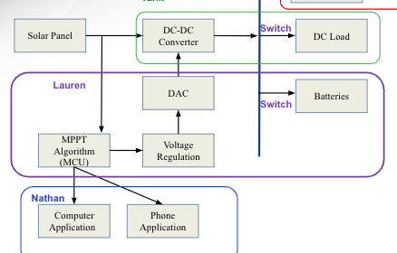

**Figure 2.1: Subsystem Overview (Purple Highlight)**

Additionally, the Microconroller system must be able to communicate across the internet to report fluctuations in data. It must report the solar panel and battery’s voltage and current across the wifi to the backend realtime database.

1. **Subsystem Design**

***2.1 Max Power Point Tracking***

The max power point tracking (MPPT) subsystem was designed to regulate the power from the solar panel as it may fluctuate due to the different loads of the overall system. Specifically, the MPPT sends a signal, from the microcontroller, to the DC-DC converter to increase the voltage to the overall system based on the inputs from the voltage and current sensors. This change happens within milliseconds to ensure that there is no damage to the system due to a sudden surge or loss of power.

***2.2 MPPT PCB***

The Max Power Point Tracking design utilizes the ESP32 Microcontroller which has enough analog and digital pins and computation power to meet the requirements of the Solar/Battery Power System. It has twenty three analog/digital pins, two of which are also digital to analog output pins. This meets our needs as the subsystem consists of six sensors (analog input), one digital to analog converter output, and two switches (digital output). A voltage regulator rated for 3.3V output was used to supply power to the ESP32 from the 12V battery. Additionally, all inputs are converted to a 3.3V or less value to avoid damage to the ESP32.

This subsystem continuously reads inputs from all 5 sensors to maintain the logic communication with the switches. For example, when the solar power and battery both do not have enough power to supply to the loads the system goes into shut down mode resulting in all switches to open so there is no flow of current or voltage. The microcontroller is programmed to respond to these various scenarios to ensure proper operation.

A PCB was designed using Altium with the help of Tarik Dawson. Once the board was printed the design changed by taking out the UART connection and reconnecting the power supply to the board. We flashed code by using a direct connection to the board and a USB TTL serial connection.

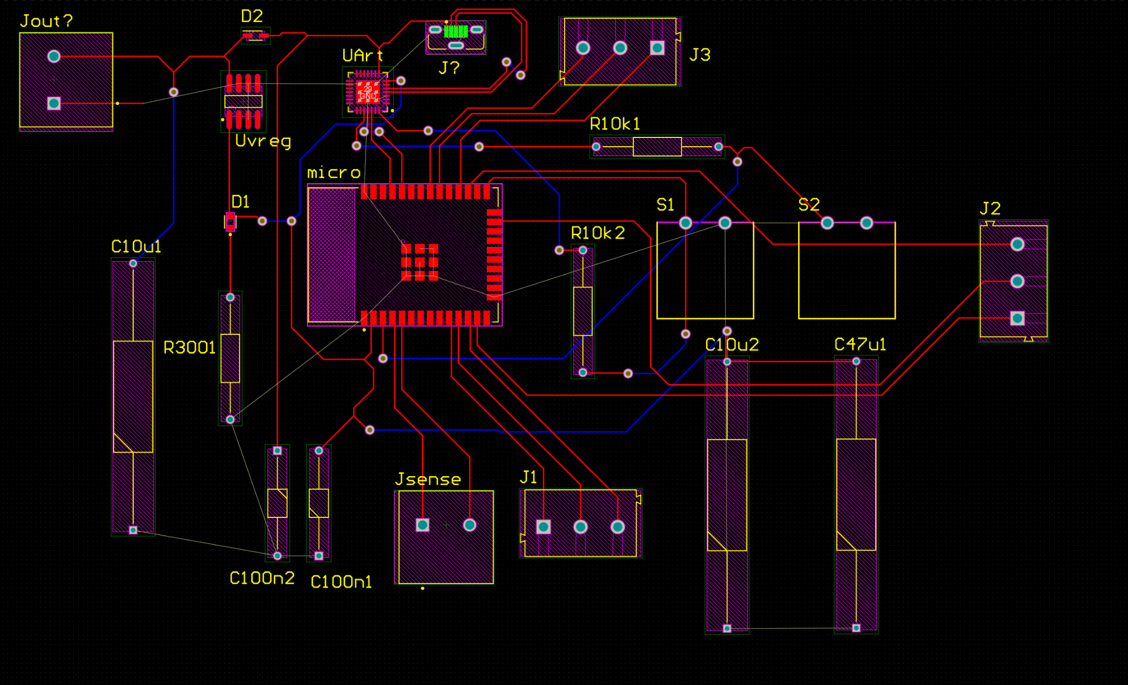

**Figure 2.1: PCB design of Microcontroller**

***2.2 MPPT Code***

The method to determine the max power point tracking is based on the current and voltage coming from the solar panel. The flowchart below summarizes its operation. The desired voltage supplied to the DC-DC converter is a minimum of 12 volts. The voltage and current values from the solar panel are taken and are compared to the previous values. If the previous values are different the DAC voltage output changes to adjust to increase the power accordingly. The maximum voltage sent from the ESP32 to the DC-DC converter is 1.2 volts which outputs approximately 12.06V. If a voltage boost is required the system drops the voltage sent by 0.1V until the Solar Panel is corrected. The relationship between output voltage from the microcontroller $V_{m}$ and the voltage of the DC $V_{DC}$.

$V_{DC} = -4.81V_{m}+ 17.8$

Additionally, if the solar panel is not producing current and the voltage is lower than 30V then the switch is opened between the solar panel and the battery is connected to the DC output. If the battery drops below 10.5V and the solar panel no longer is producing power then the whole system is shut down. However the battery is able to charge when the solar panel is producing power and the switch from the DC will connect to the battery to recharge.



**Figure 2.2: Flow Diagram of Sensor Response**

However, this diagram does not include the input of the sensors between the DC-DC converter to the load. These sensors were read as inputs but have yet to have specifications due to the lack of data from the DC-DC converter to understand the measurements.

***2.3 Current and Voltage Sensors***

**2.3.1 Design**

The current and voltage sensors are the most critical to this subsystem because they are used to estimate the power from the solar panel. Maintaining the maximum power from the solar panel ensures that the Solar/Battery Power System works correctly, which requires accurate measurements of the output. Additionally, maintaining the battery supply is crucial in preparation for nightfall or cloudy weather when solar energy may be less prominent. The battery supply has only been measured by the voltage sensor for this system. The last two sensors are between the DC-DC converter and the DC load, to ensure the converter is outputting the expected amount.

The current sensor was designed using a 10 mOhm resistor and a OpAmp (MAX4080). This version of the OpAmp was used with a gain of 5 for the two places before and after the DC-DC converter. The current sensor at the battery is 50 % gain. We choose to do this due to the limited amount of parts and cost. The 50 gain OpAmps were bought first due to a misunderstanding.

The voltage sensor designed utilized a voltage divider. The voltage sensor before the DC-DC converter used a 2.2 kOhm and a 100 Ohm resistors. The voltage sensor before the battery and after the DC-DC converter both used a 1.2 kOhm and a 4.7 kOhm resistors. The voltage dividers are different because the maximum input from the solar panel is 60V. The maximum voltage for the battery and DC-DC converter are both 12V.

All sensor outputs are sent to the microcontroller for evaluation and integrated into the max power point tracking system.

**Figure 2.3: Voltage and Current Sensor Schematic**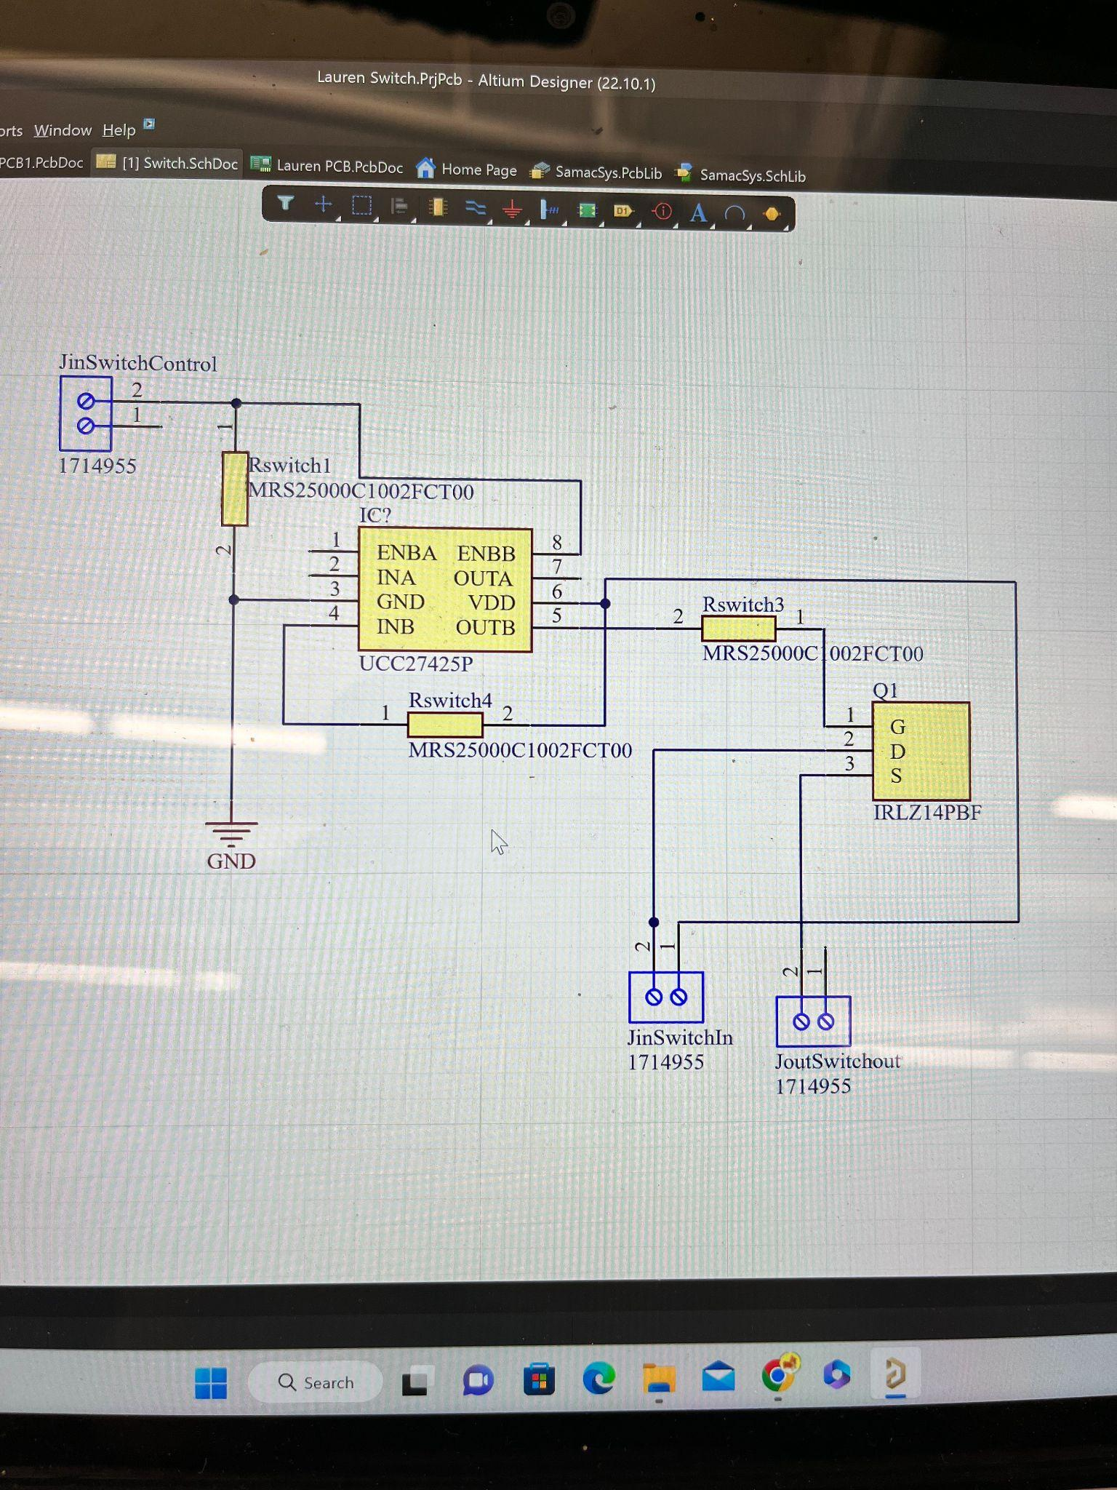

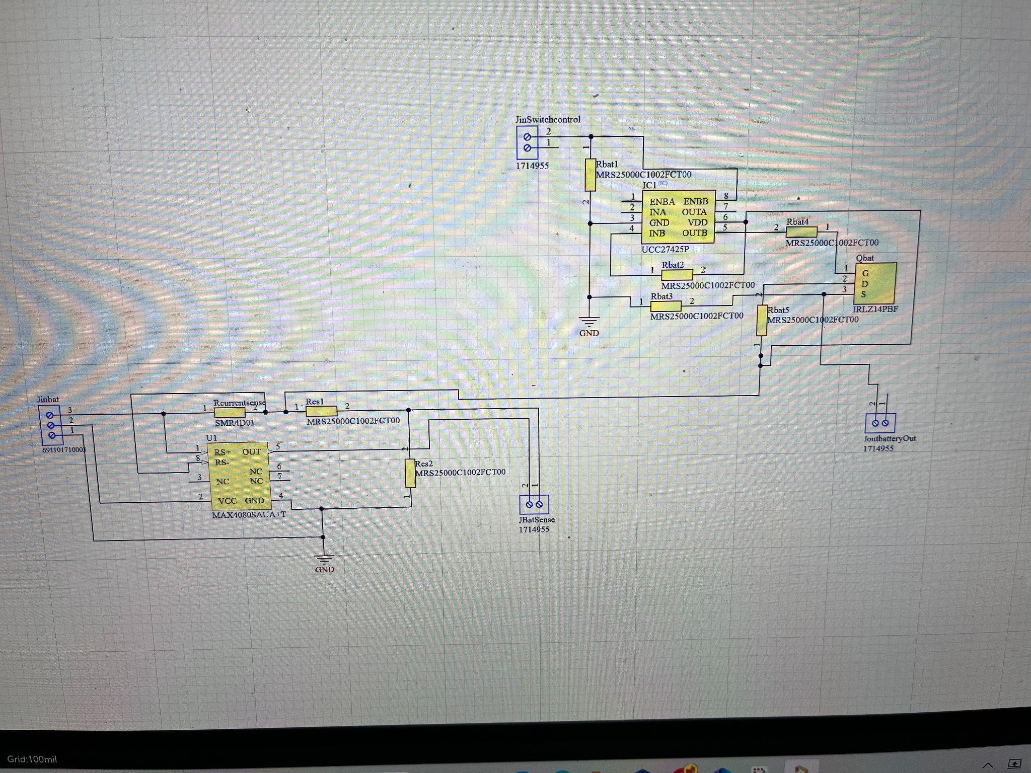

**Figure 2.4: Battery Voltage/Current Sensor and Switch Schematic**

***2.4 Switches and Output to DC-DC Converter***

**2.4.1 Operation**

The design of the switches changed by eliminating one switch due to the large amount of expected current from the solar panel. It was difficult with the device storage to find parts that would meet all of our systems requirements. It was decided that only one switch was needed to disconnect the solar panel from the system instead of two. The switches maintain the system and control the power flow to the various subsystems. The switches consist of a gate driver and a mosfet. The input is controlled by the microcontroller and the power supply comes from the 12V battery or the DC-DC converter depending on the closest source within the integrated system. The switch between the DC-DC converter and the AC inverter is supplied by the DC-DC converter system. The battery switch is supplied by the battery flow. The switches operate by receiving an enable signal from the microcontroller to close the switch or allow the flow of power. When the signal is high(3.3V) the switch is opened and when the signal is low(0V) the switch is closed.

***2.4 Connecting to the Realtime Database***

This subsystem works in collaboration with the Computer and Phone Application to send the evaluated sensor data for the user to have easy access. The ESP32 connects across the wifi to send the sensor data to the backend database. The ESP32 already has a built-in system to transmit wifi and each data point was converted to JSON to transmit the data. When the data from the sensors is received by the ESP32 the program design converts the data appropriately to their true values. Only the solar panel and battery current and voltage were sent to the database to plot the efficiency of the solar panel and inform the user the state of the battery. The database was updated approximately every 2 minutes to give accurate information over a 24 hour window. All the data processing, after being received by the realtime database, to the user applications was designed by Nathan Gil.

1. ***Subsystem Validation***

***3.1 Sensor Validation***

The sensors were monitored across the EPS32 initially using a development board to easily change the inputs and visibly see the updates to the realtime database. The same code was flashed to the ESP32 PCB board and again monitored from a laptop. The current values were tested using a load by Tarik Dawson for the sensors on the DC-DC converter subsystem. The current values across the battery were tested in the integration system and was steadily 0 Amps which was expected.

The circuit between the Solar Panel and the DC-DC converter was tested using up to 25 volts using a voltage supply and in connection with the solar panel up to 30 Volts. No higher measurement was taken due to the limit on the voltage supply. The circuit between the DC-DC Converter and the DC load was tested up to 12V, which is the expected output of the DC-DC Converter. Finally the circuit measuring the battery voltage was again tested using 12V. All final results were tested simultaneously with the microcontroller to ensure a proper input was produced. All sensors worked as expected.

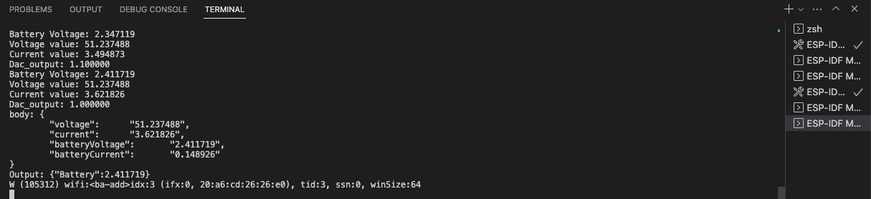

**Figure 2.5: Sensor Monitor Output**

***3.2 Switch Validation***

The switches were tested by applying a signal to the enable pin before connecting to the microcontroller to ensure that they allowed the flow of power throughout the system when triggered. The ESP32 was connected and voltage supply inputs were used to trigger the switches to close and open. The microcontroller was fully able to ensure this change. However when the full system was put together the switch had difficulty changing at the proper time. This is most likely caused by the conversion of the current and voltage sensors not being accurate and thus not triggering the system. The data below represents a test with the ESP32 Development Board.

|  | Battery Switch | Solar Panel Switch |
| --- | --- | --- |
| Battery Fully Supplied and Solar Panel > 30V | Off | On |
| Battery < 10.5 and Solar Panel > 30V | On | On |
| Battery < 10.5 and Solar Panel < 30V | Off | Off |

**3.3 Code Validation**

Max Power Point Tracking was tested again using various voltage and current inputs to monitor the change in across the DC-DC converter and switches. To test the MPPT the voltage sent to the current sensor was lowered to simulate a lower current. The voltage to the DC-DC converter was lowered until the system was supplied with an accurate voltage. When the voltage input across the current sensor was turned higher the voltage went back to 1.2V. The figure below shows the change in the DC Output when current is lowered.

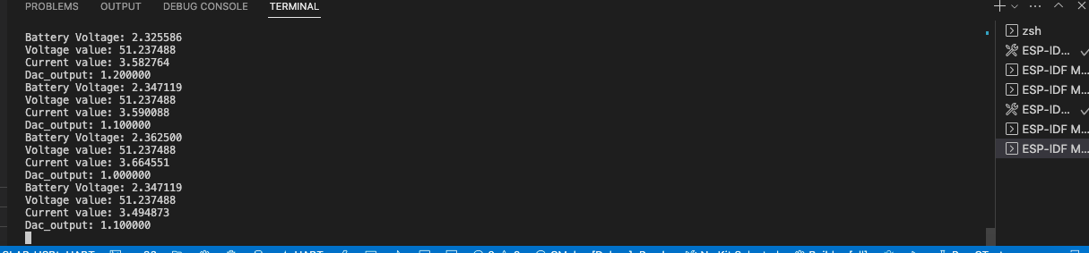

**Figure 2.6: Monitor Response for MPPT**

To test the code send over the wifi to the real time database. As the voltages changed over a period of time we continuously send data to the database to ensure that the values were changing as the microcontroller was reading the inputs. We also watched the time in order to determine how fast the data was moving and as previously mentioned we were sending data every 2 minutes. Below are the results of the data being sent to the database.

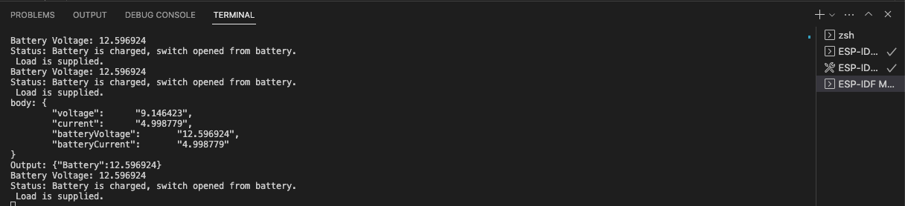

**Figure 2.7: Data Sent across Wifi**

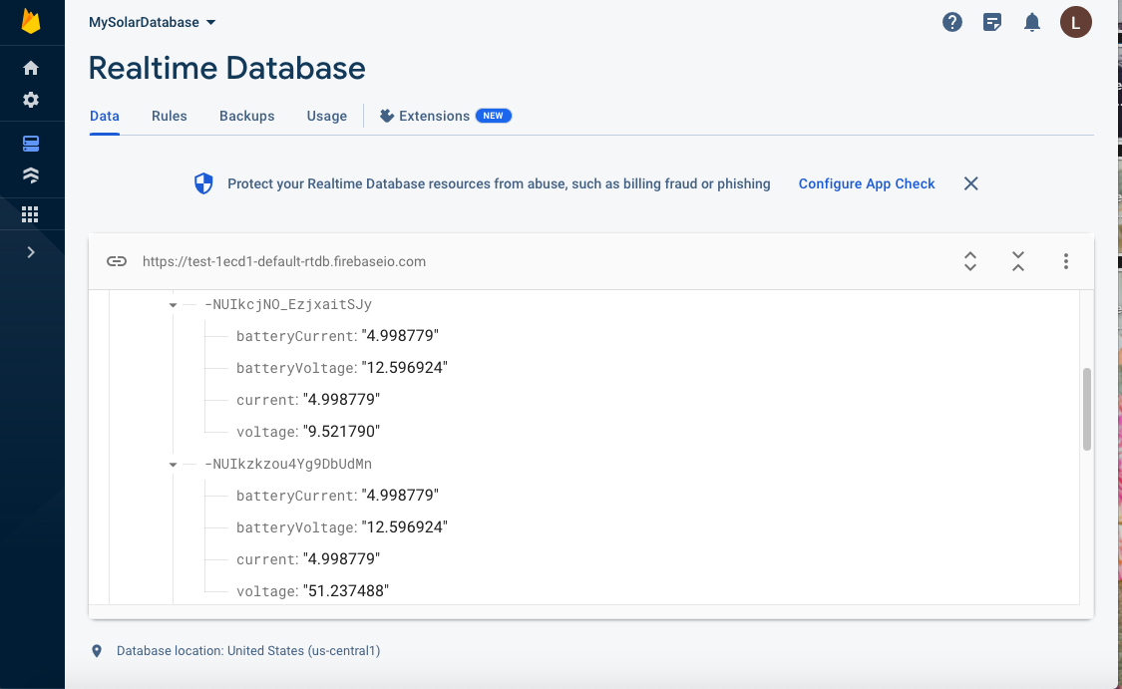

**Figure 2.8: Realtime Database Data**

1. ***Subsystem Diagnostics***

The Microcontroller and Switch/Sensor Subsystem did encounter some problems during testing and validation. The main issue was being able to flash the code from a computer to the ESP32 PCB board. First, the voltage regulator originally used on this board was outputting 3.8V instead of 3.3V which is over the max limit for the ESP32 to handle. This was solved by switching out the part for another. Another issue that was encountered was the UART and USBc Connection. It was very difficult to determine how to connect the UART and USBc, which was eventually abandoned in favor of making a direct connection to the transmitting and receiving using a USB TTL. However, this connection brought on unforeseen connection issues. While there was a direct connection to the transmitting and receiving pins on the ESP32 the UART was still controlling those pins at the same time. The solution was to remove the UART and reconnect the power supply directly to the ESP32.

Due to the time constraints and the delay to flashing our ESP32 properly we encountered problems with the code that were unable to be resolved before our final demonstration and presentation. Specifically, the issue was with the conversion of the voltage and current values from the ESP32 PCB board. When testing this code on the EPS32 development board we did not have many issues with the switches turning on and off at appropriate times. However, these tests were run under extreme conditions when voltage/current is supplied at distinct values (3.3V, 3V, 2V, 1V,and 0V into the ESP32). If the system was tested with a larger range of value the sensors would have more accurate conversions. Additionally, this may also be a problem with the PCB design itself which again there was not enough time to properly investigate. The mechanical components themselves worked well at triggering the switch which leads us to the conclusion that there must be a problem within the code itself.

1. ***Future Workings***

If given more time and a larger budget I would fix several things for the microcontroller sensor/switch subsystem. Specifically, I would optimize the voltage and current conversions and troubleshoot the issue surrounding the switch system. Additionally, I would redesign the ESP PCB to accommodate the change from UART to the TTL system to decrease the amount of loose wires in the system.

1. ***Subsystem Conclusion***

The microcontroller and sensor/switches subsystem is a critical part of the Solar Power Battery System and communicates with all of the other subsystems. This subsystem was successfully designed to take voltage and current inputs from different parts of the circuit and send them to the ESP32 for analysis. The system was able to take in these values and send them across wifi to the realtime database. This will allow the user to monitor the power trends within 24hrs. Additionally, the max power point tracking self regulates the voltage boost to the DC-DC converter to optimize the power from the solar panel. This allows the solar panel to supply the system for longer. The system can also handle any sudden changes in power being supplied due to change in lighting. A future modification to this subsystem would be to implement an accurate conversion of current and voltage sensors over a large range of values.

Overall from this project I learn a lot of valuable skills. I learned a new programming language, ESP-IDF, and an understanding of how microcontrollers work to regulate other systems. I learned how to solder and debug a PCB board. Also, I learn how to determine what parts to use in a PCB design and how to properly read a datasheet. Most importantly, any task that needs to be completed will take 3 to 4 times as long as you planned and the team should plan accordingly. In terms of soft skills, I gained experience on working on a team where all systems needed to be mindful of each other in terms of designs and progress. Overall, I have a better understanding of project development.

Solar/Battery Power System

Tarik Dawson

**DC-DC Converter Subsystem Results**

Final Draft

27th April 2023

**1. *Introduction***

To power any device connected to the system and to charge the battery, the Solar/Battery Power system must receive and distribute power as needed. The DC-DC converter subsystem is designed to take variable DC voltage from a solar panel and output 12V DC voltage by bucking or lowering the voltage while increasing the current. This converter was designed to be able to output as much as 10 amps of current while taking in up to 5 amps from the input. This output will supply power to the rest of the subsystem via a bus to either charge a battery, supply input power to the DC-AC converter, or supply an external DC load. The converter will also be able to change its output voltage via feedback from the MPPT subsystem. This subsystem also has two current and voltage sensors as well as a switch. One set of voltage and current sensors between the solar panel and the DC-DC converter and another after the output of the converter. The switch is placed after the output to act as an off switch. The subsystem was tested to ensure it functioned as expected.

1. ***Subsystem Design***



**Figure 2.1: Block diagram of DC-DC Converter Subsystem**

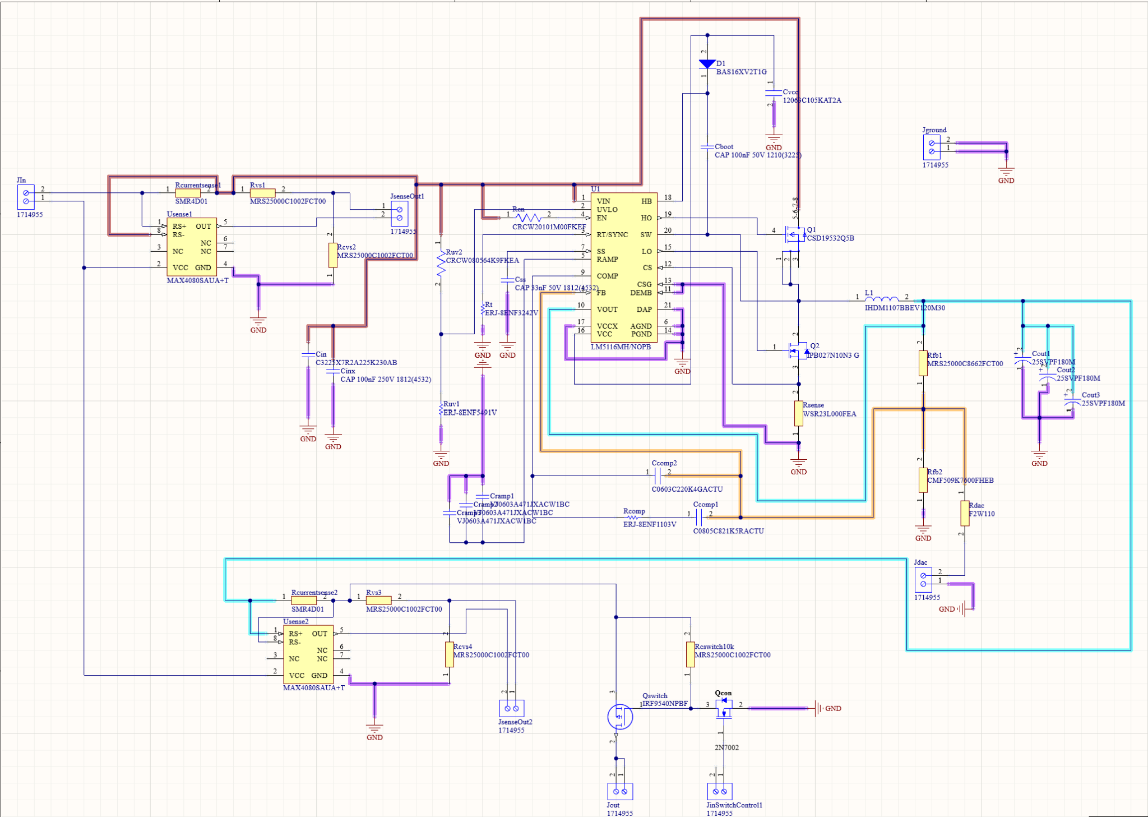**Figure 2.2: Schematic of DC-DC Converter Subsystem**

The primary challenge of the subsystem was ensuring that the subsystem and all of its parts could handle the high currents that flowed through it. This was accomplished by specifically ordering parts that were rated higher than the absolute max current and voltage this system could produce and by ensuring all traces were of sufficient width using a trace width calculator. Another challenge was the fact the subsystem could not be simulated on any application, which led to many redesigns along the way to the finished product.

***2.1 DC-DC Converter***

The DC-DC converter subsystem was designed to take 20V through 60V input DC voltage from a solar panel and output 12V DC voltage up to 20 amps. The system uses a LM5116 buck controller chip to control the gates of 2 MOSFETs to form a buck converter that outputs the desired value of 12 volts while taking in a feedback voltage to adjust the output voltage on command.

***2.2 Feedback***

The feedback system was designed using a current injection method where an outside source (microcontroller) would be a factor in the feedback response of the LM5116 chip. The calculated equation for the output voltage with the current injection feedback system is

$Vout = 1.215*(1+(Rfb1/Rfb2)) + ((1.215 - Vfeedback)*(Rfb1/Rdac))$

***Equation 1***

where Rfb1 = 86600 Ohms, Rfb2 = 9760 Ohms, Rdac = 18000 Ohms, and Vfeedback is supplied by the microcontroller. This was intentionally designed to take 0V to 3.3V as Vfeedback as that is the limit of what the ESP32 microcontroller can supply. The first design of this system included a diode before the Rdac, but this was quickly seen as an error and removed.

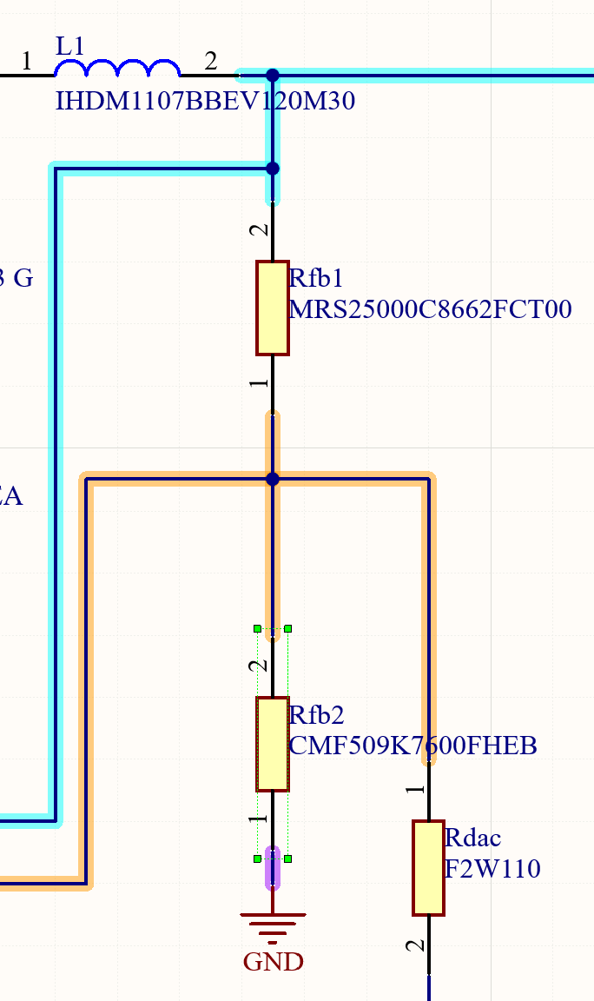

**Figure 2.2: Schematic of the Feedback for the DC-DC Converter**

***2.2 Power source***

The DC-DC converter subsystem and subsequently the rest of the systems are powered via solar panel or via a battery that is charged with the solar panel.The solar panel for this system was a 240W panel rated for 60V 5A output and used to supply the loads and charge the battery.

***2.3 Sensors***

In order for the system to work as intended, the microcontroller subsystem must receive both current and voltage data to facilitate MPPT and to provide information to the website/application. The design of these current and voltage sensors was done by Lauren Lugo, who is in charge of the microcontroller subsystem, please refer to her subsystem report. The voltage sensor was made using a “voltage divider” design, such that the sensor output voltage stayed between 0 and 3.3V so as to not damage the microcontroller while simultaneously giving an accurate ratio of the voltage. The current sensor was made using a MAX4080FAUA op-amp with 5 gain to measure voltages across a 10 mOhm resistor to give an accurate measure of the current. The current sensor was also designed such that the current sensor output would stay between 0 and 3.3V There are two current and voltage sensors in the current subsystem design. One before the DC-DC converter to measure the output voltage and current of the solar panel, and one placed after the DC-DC converter to measure the output of the converter itself. The current sensors were supplied 3.3V to power them. The original design of the current sensors had op-amps with 60 gain, which would burn out the microcontroller as the voltage would be too high. This was quickly corrected to the current version.

***2.4 Switch***

The subsystem was designed to be able to be disconnected from the rest of the system vai a switch. Using two mosfets, a IRF9540NPBF and a 2n7002, a simple high side switch was designed and implemented into the DC-DC converter subsystem after the output sensor. Shown below is a schematic of the switch. The first design of the system was a low side switch that used a gate-driver and a mosfet to switch the load on or off. This ended up not working due to the nature of low-side switches and the current design was implemented.

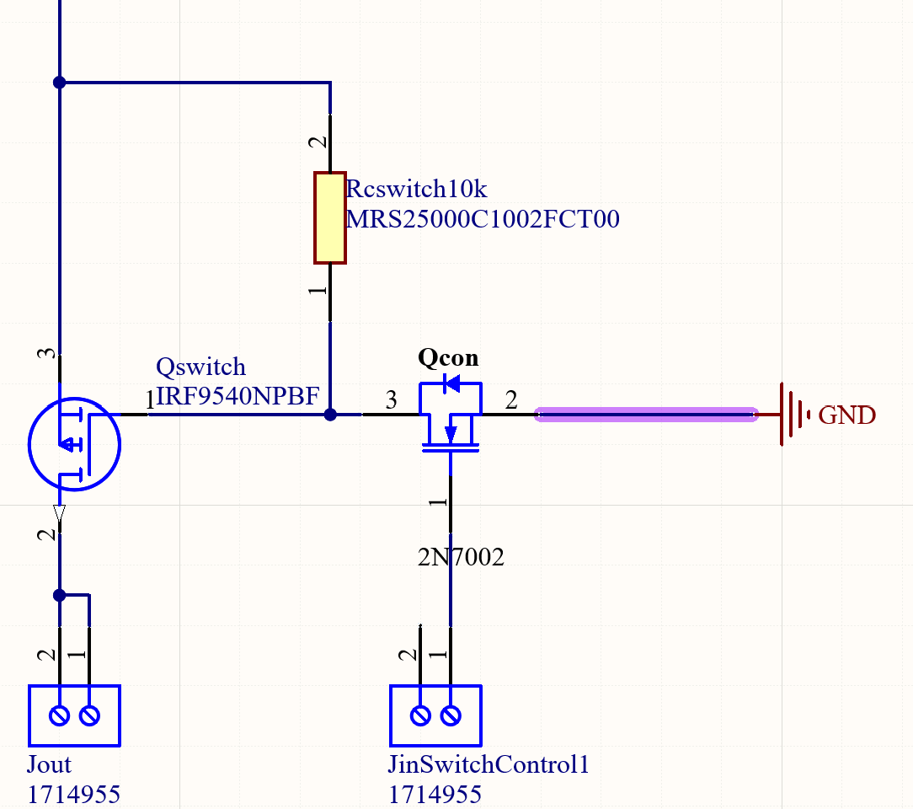

**Figure 2.2: Switch Schematic**

***3.1. PCB Design***

The DC-DC converter subsystem was designed using Altium designer and is shown below.

This particular design consists of two layers, a top and bottom layer, along with terminal blocks for inputs, outputs and feedback.

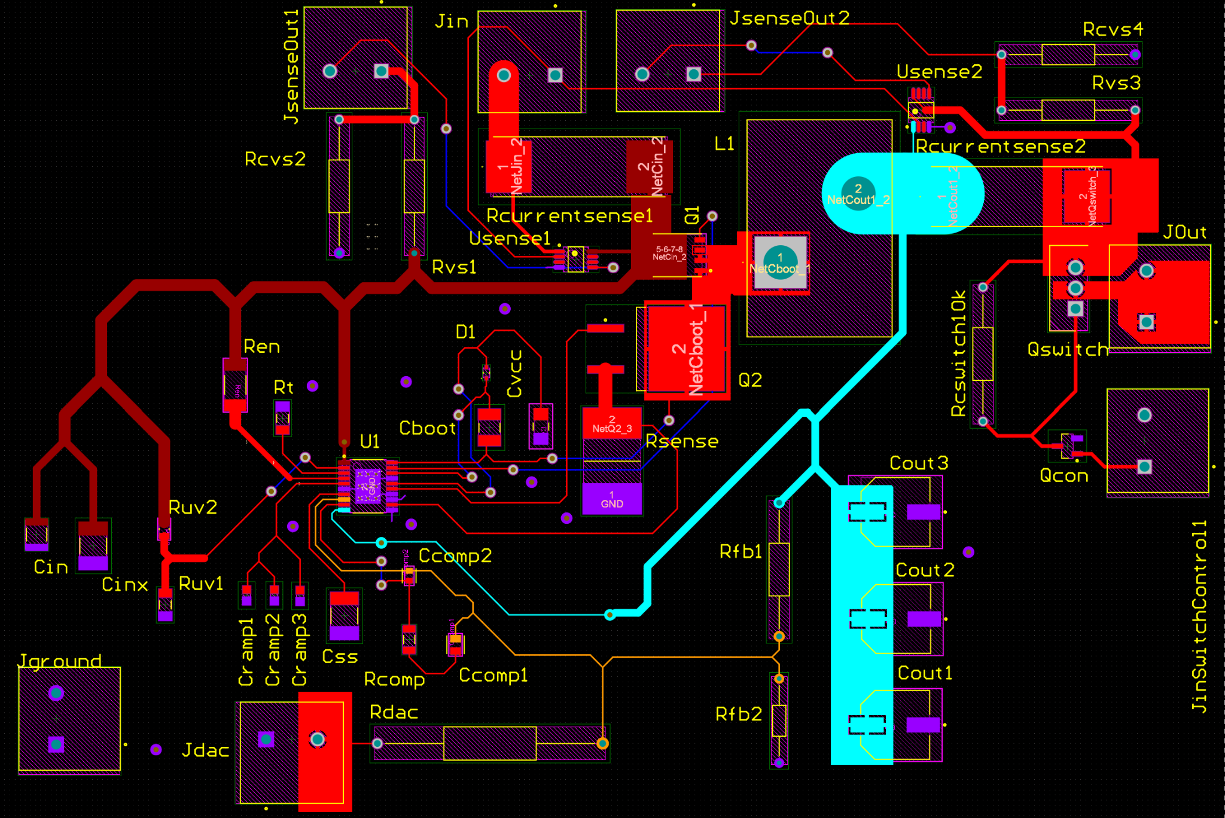

**Figure 3.2: 1st layer of DC-DC PCB**

*\*It should be noted that the ground plane is shelved for sake of clarity.*

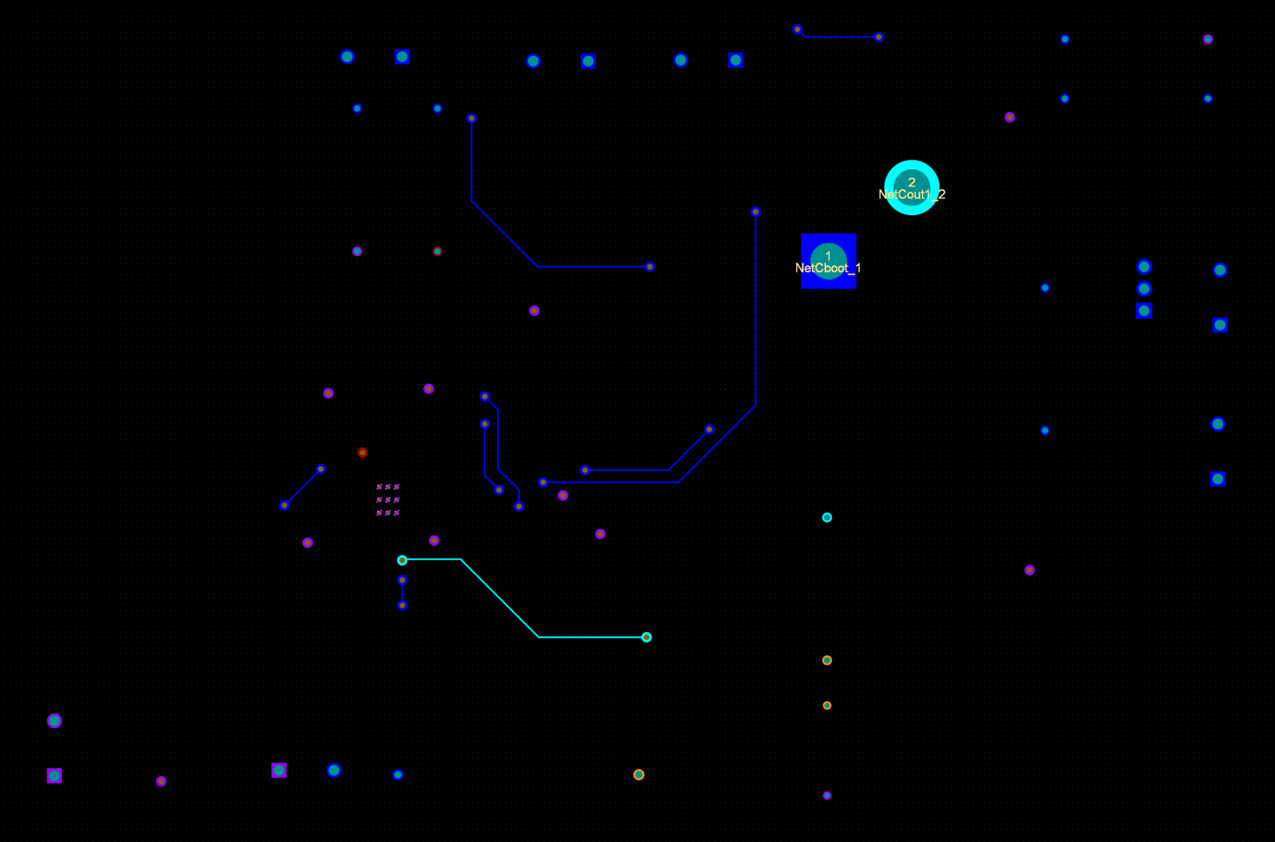

**Figure 3.3: 2nd Layer of the DC-DC PCB**

*\*It should be noted that the ground plane is shelved for sake of clarity.*

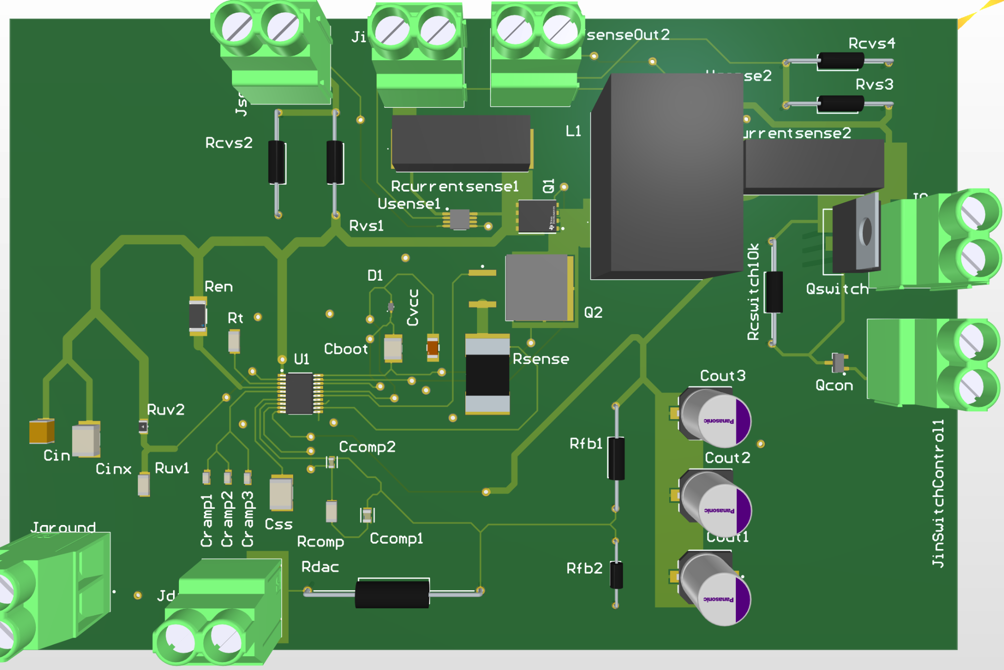

**Figure 3.3: 3D model of the DC-DC PCB**

***4. Subsystem Validation***

***4.1 Input range Validation***

This subsystem needs to be able to function as intended over all the possible input voltages. The first validation test for this subsystem was the variable input voltage test. This test was done by connecting the converter to a high power supply for input and an Eload in constant current mode set to 2.018 amps. Below is the result of that test.

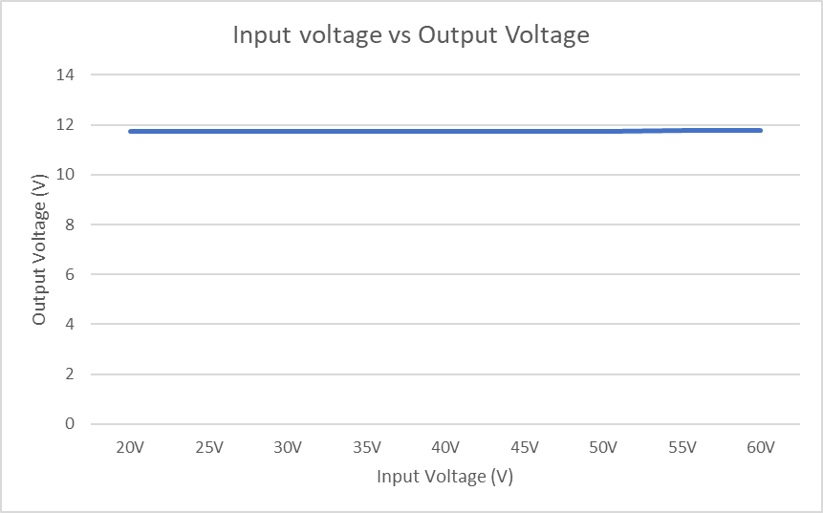

***Figure 4.1: System Input vs Output voltage***

***Figure 4.2: Zoom in of System Input vs Output voltage***

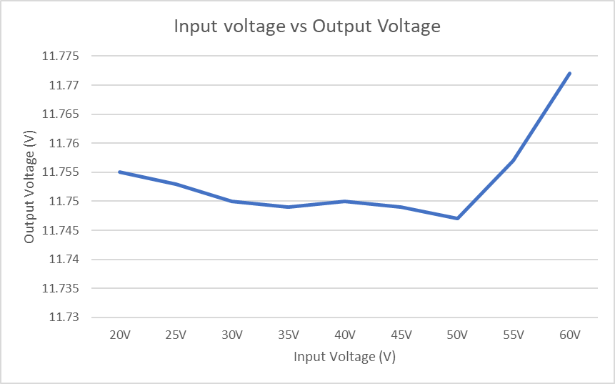

The data shows that the system outputs close to 12V DC output for varying inputs from 20V to 60V DC. This shows that the subsystem will be able to handle all input voltages from the solar panel.

***4.2 Efficiency Validation***

The subsystem must have a reasonable efficiency to work properly, there is no use for a converter that takes 200 watts and outputs 2 watts. Thus, a test was done to validate that the subsystem was efficient. Using data gathered from the variable voltage test, efficiency of the system was calculated to be around 80%.

***Figure 4.3: Efficiency vs Input Voltage***

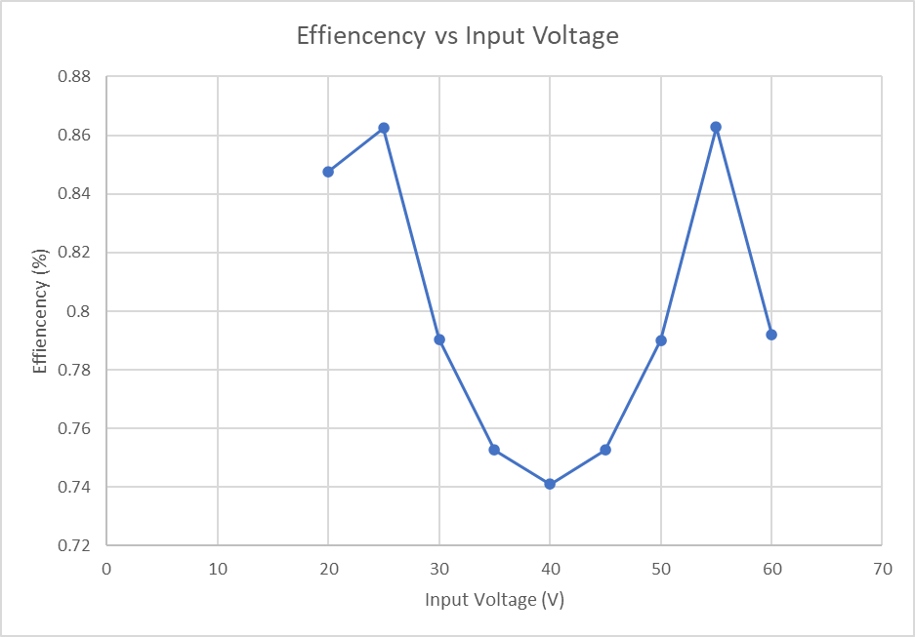

***4.3 Load Current Validation***

This subsystem must be able to power most loads that are attached to it. To confirm that the system will be able to accomplish this task, a validation test was conducted where the converter was supplied a constant voltage and was attached to an Eload to facilitate an increasing load. Below is the graph that shows how the system responds to various current loads from 0 amps to 3 amps. Control voltage was set to a constant 1.2V

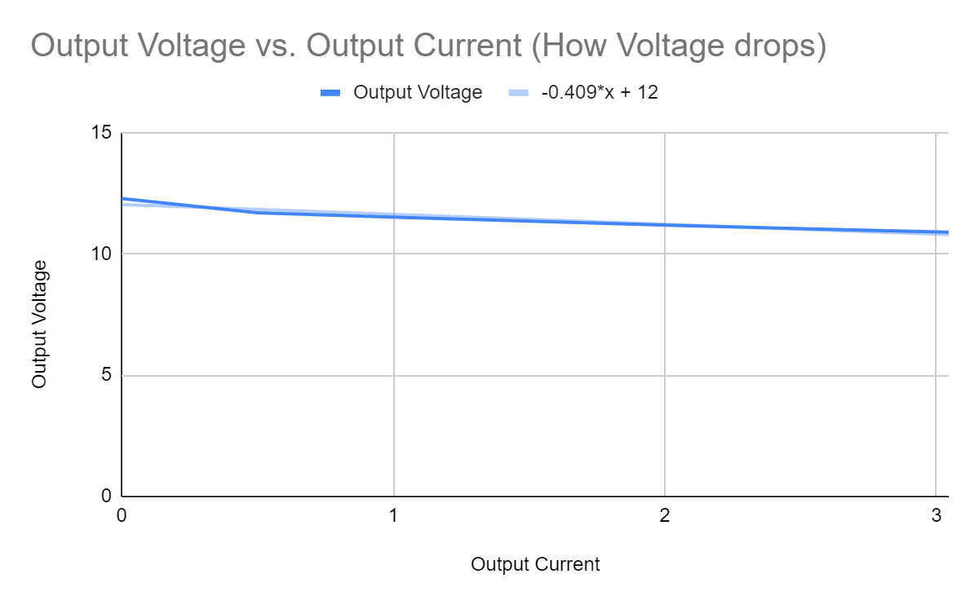

***Figure 4.4: Output Voltage vs Output Current***

It should be noted that the system could not handle more than 5 amps safely, this will be discussed further in future work sections of this subsystem report. This data shows that the Voltage stays around 12V as the load is increased. The data also characterizes how voltage drops as load increases.

***4.4 Feedback Validation***

This subsystem includes the ability to change the output voltage based on an input voltage taken from an external source. This was validated by performing a test in which the feedback voltage (input voltage from the microcontroller) was varied from 0V to 1.2V. The input voltage was set to 30V and the load current was set to 1.0A using the Eload device.

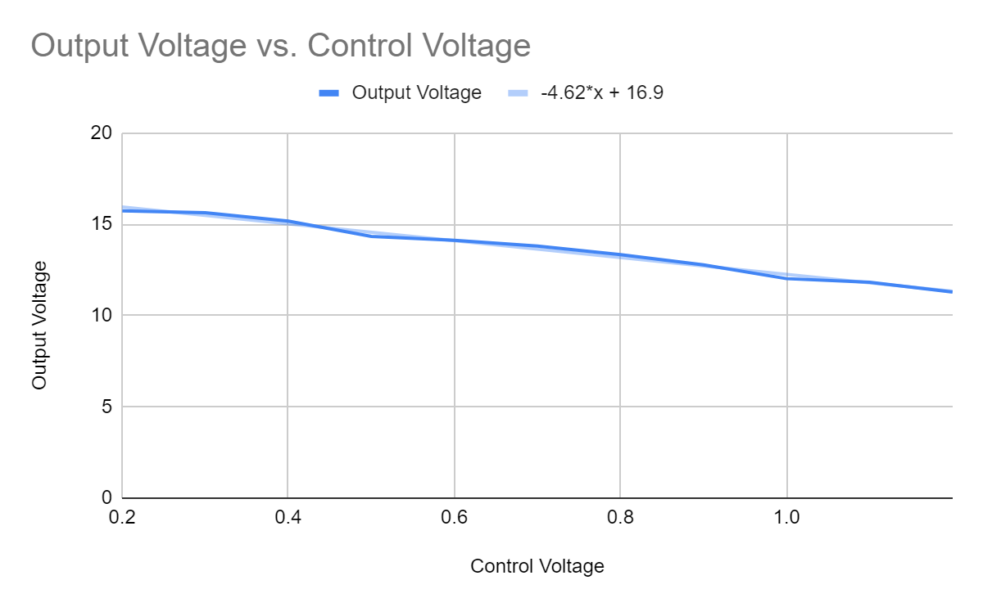

***Figure 3.8: Output Voltage vs Feedback Voltage***

This data shows the output voltage is responsive to the control voltage supplied by the microcontroller. The microcontroller will calculate when to decrease the control voltage to increase the output voltage.

***4.5 Sensor Validation***

This subsystem reads current and voltage from the input and the output of its system and supplies this data to the microcontroller to be used in calculations or to be transmitted to the website/application. Below are the various sensor tests performed to ensure that the microcontroller was receiving the correct data. The first test performed was to characterize the ratio between the input voltage and the output of the input voltage sensor. This is shown below.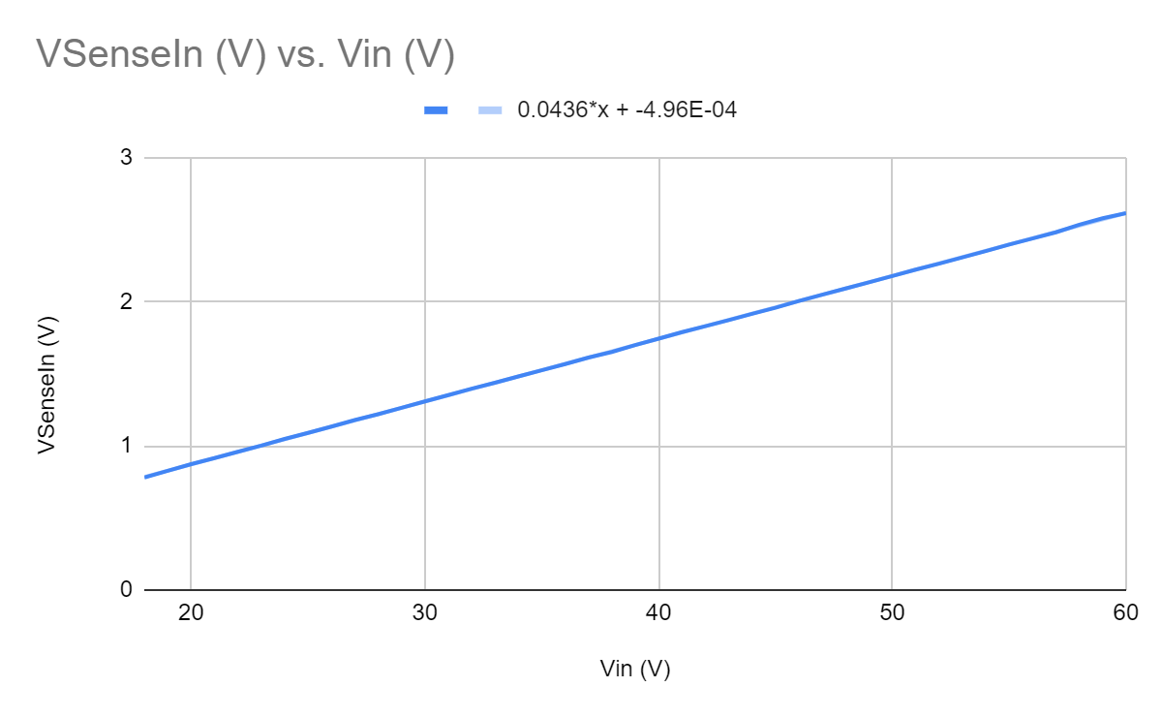

***Figure 3.8: Input Voltage vs VsensorIn Voltage***

This data shows that the input voltage sensor performs as expected, providing a voltage between 0V and 3.3V that represents the input voltage of the system.

The next test performed was to characterize the relationship between input current and the output voltage of the current sensor. This is shown below.

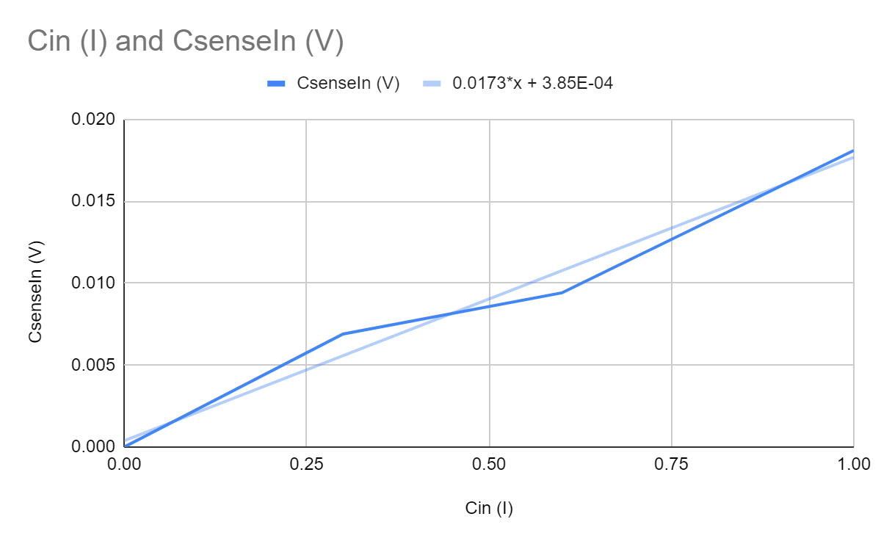

***Figure 3.8: Input Current vs CsenseIn Voltage***

This data shows that the input current sensor performs as expected, providing a voltage between 0V and 3.3V that represents the input current of the system.

The next test performed was to characterize the relationship between output voltage and the output of the output voltage sensor. This is shown below.

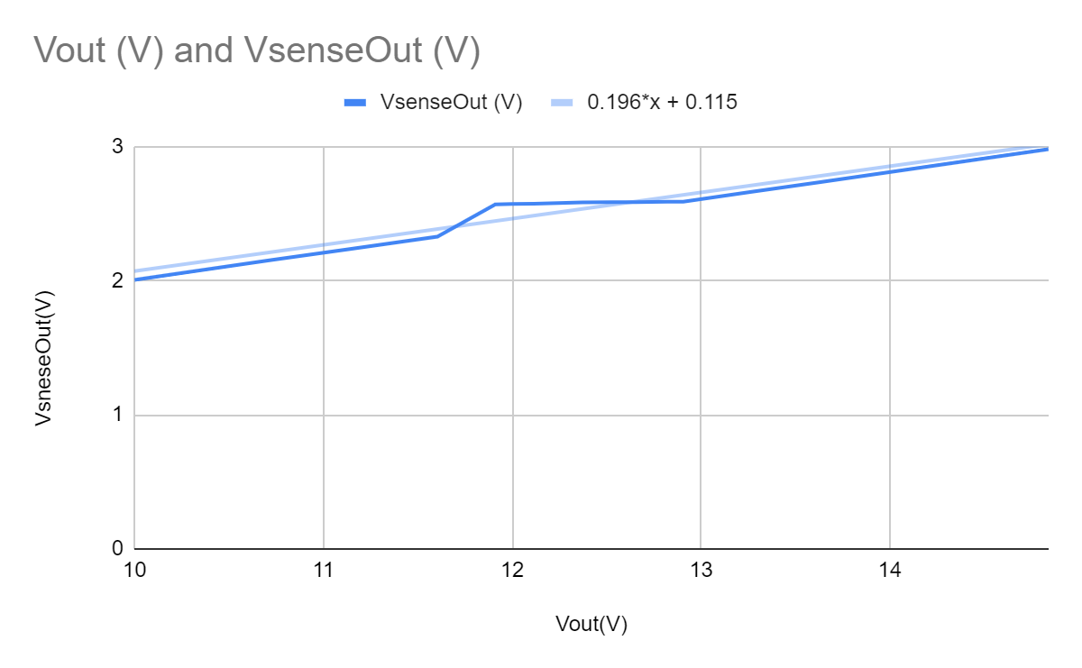

***Figure 3.8: Output Voltage vs VsenseOut Voltage***

This data shows that the voltage sensor performs as expected, providing a voltage between 0V and 3.3V that represents the output voltage of the system.

The next test performed was to characterize the relationship between output current and the output of the output current sensor. This is shown below.

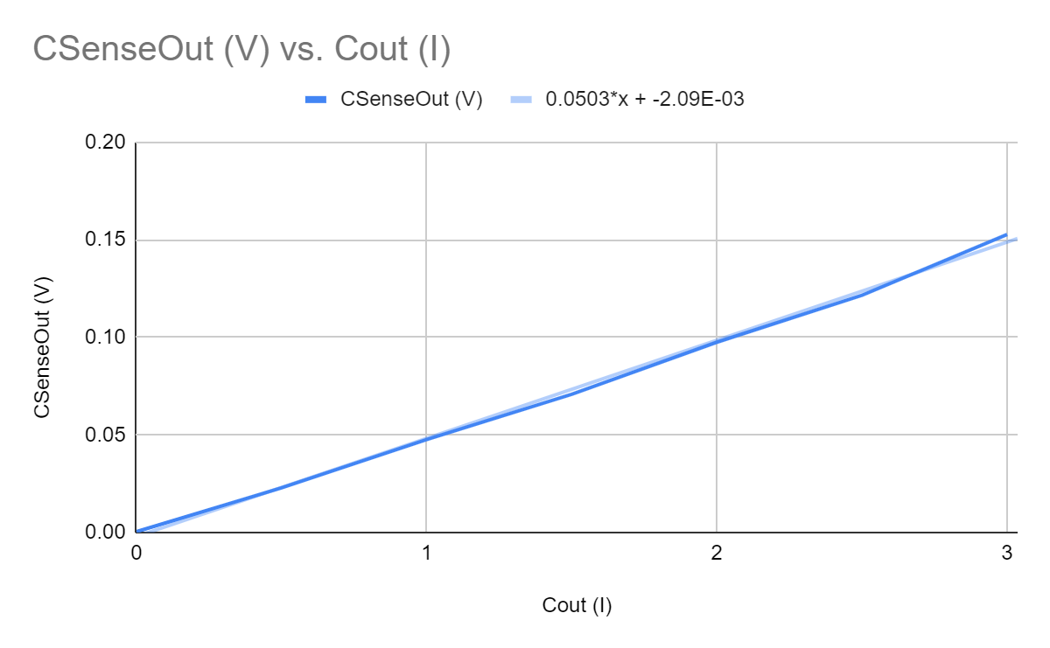

***Figure 3.8: Output Current vs CsenseOut Voltage***

This data shows that the current sensor performs as expected, providing a voltage between 0V and 3.3V that represents the output current of the system.

***4.6 Switch Validation***

The DC-DC converter subsystem had the ability to disconnect from the rest of the system through a high-side switch. A test was performed to ensure that the subsystem does so via a signal from the microcontroller in which the system was connected to a E-load pulling 1A, control voltage was set to 1.1V and supply voltage of 20V. The results of the test are shown below

| Switch control Voltage | 0V | 3.3V |
| --- | --- | --- |
| Input Voltage | 20V | 20V |
| Output Voltage | 11.7V | 0V |
| Output Current | 1A | 0A |

***Table 3.1: Switch Functionality***

This data shows that the switch performs as expected, disconnecting the subsystem from the load when provided with a 3.3V signal coming from the microcontroller.

Another test was performed later to measure something odd that was noticed. As the input voltage was raised, the switch had less and less of an effect on the output voltage, while the current response remained the same. To observe this, the subsystem was connected to the E-load pulling 1A with a varying supply voltage.Control voltage was set to 1.1V and the switch was set to 3.3V which disconnects the system. This is discussed in the future works section of this subsystem report.

| Switch control Voltage | 3.3V | 3.3V | 3.3V | 3.3V | 3.3V |
| --- | --- | --- | --- | --- | --- |
| Input Voltage | 20V | 25V | 30V | 35V | 40V |
| Output Voltage | 0V | 0.3V | 4V | 9V | 11.7V |
| Output Current | 0A | 0A | 0A | 0A | 0A |

***Table 3.2: Rising voltage vs switch***

This data shows how output voltage varies with the switch disconnecting the load based on the input voltage. This is discussed further in the future works section of this subsystem report but this data is inconsequential to the functionality of the system.

***4.7 Full Test Validation***

This DC-DC converter subsystem works as intended to a certain extent. When the load of this subsystem exceeds more than 3A, a mosfet on the switch begins to heat up, even if the mosfet is rated for 23A. This is further discussed in the future work section of the report. To test full functionality of the system an E-load was connected to the output, a 30V input was supplied to act as the solar panel, control voltage was varied to ensure that 12V was outputted, and a 0V switch signal was supplied.

| Input Voltage | 30V | 30V | 30V | 30V |
| --- | --- | --- | --- | --- |
| Input current | 0A | 0.5A | 1A | 1.5A |
| Control Voltage | 1.2V | 1.2A | 1.1A | 1.1A |
| Output Voltage | 12.2V | 11.7V | 12.02V | 11.6V |
| Output current | 0A | 1A | 2A | 3A |

***Table 3.8: Full Functionality test***

This data shows the full subsystem working as intended. As the load increases, the control will keep the output voltage stable around 12V while the switch allows current through the system. it should be noted that changing the input voltage will have no noticeable effect on the functionality of the system.

***5. Other tasks***

Aside from designing and constructing the DC-DC converter subsystem, I was tasked with building the enclosure for our whole system. Shown below is a picture of the whole system in the enclosure. Other tasks include helping PCB design of other subsystems

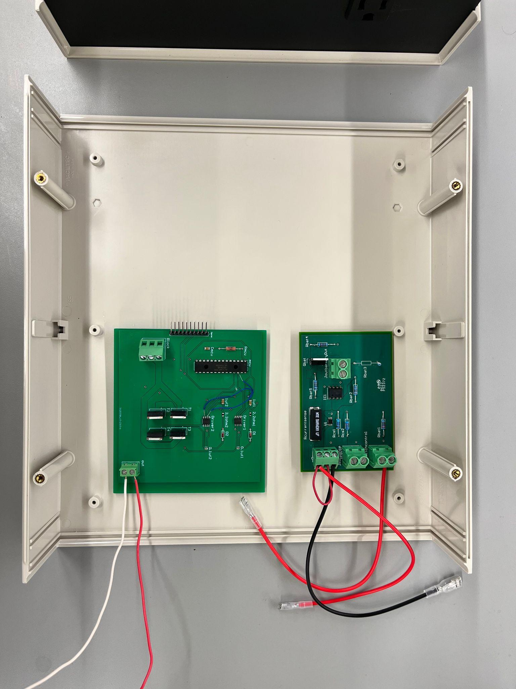

***Figure 3.8: Top Level of the Enclosure***

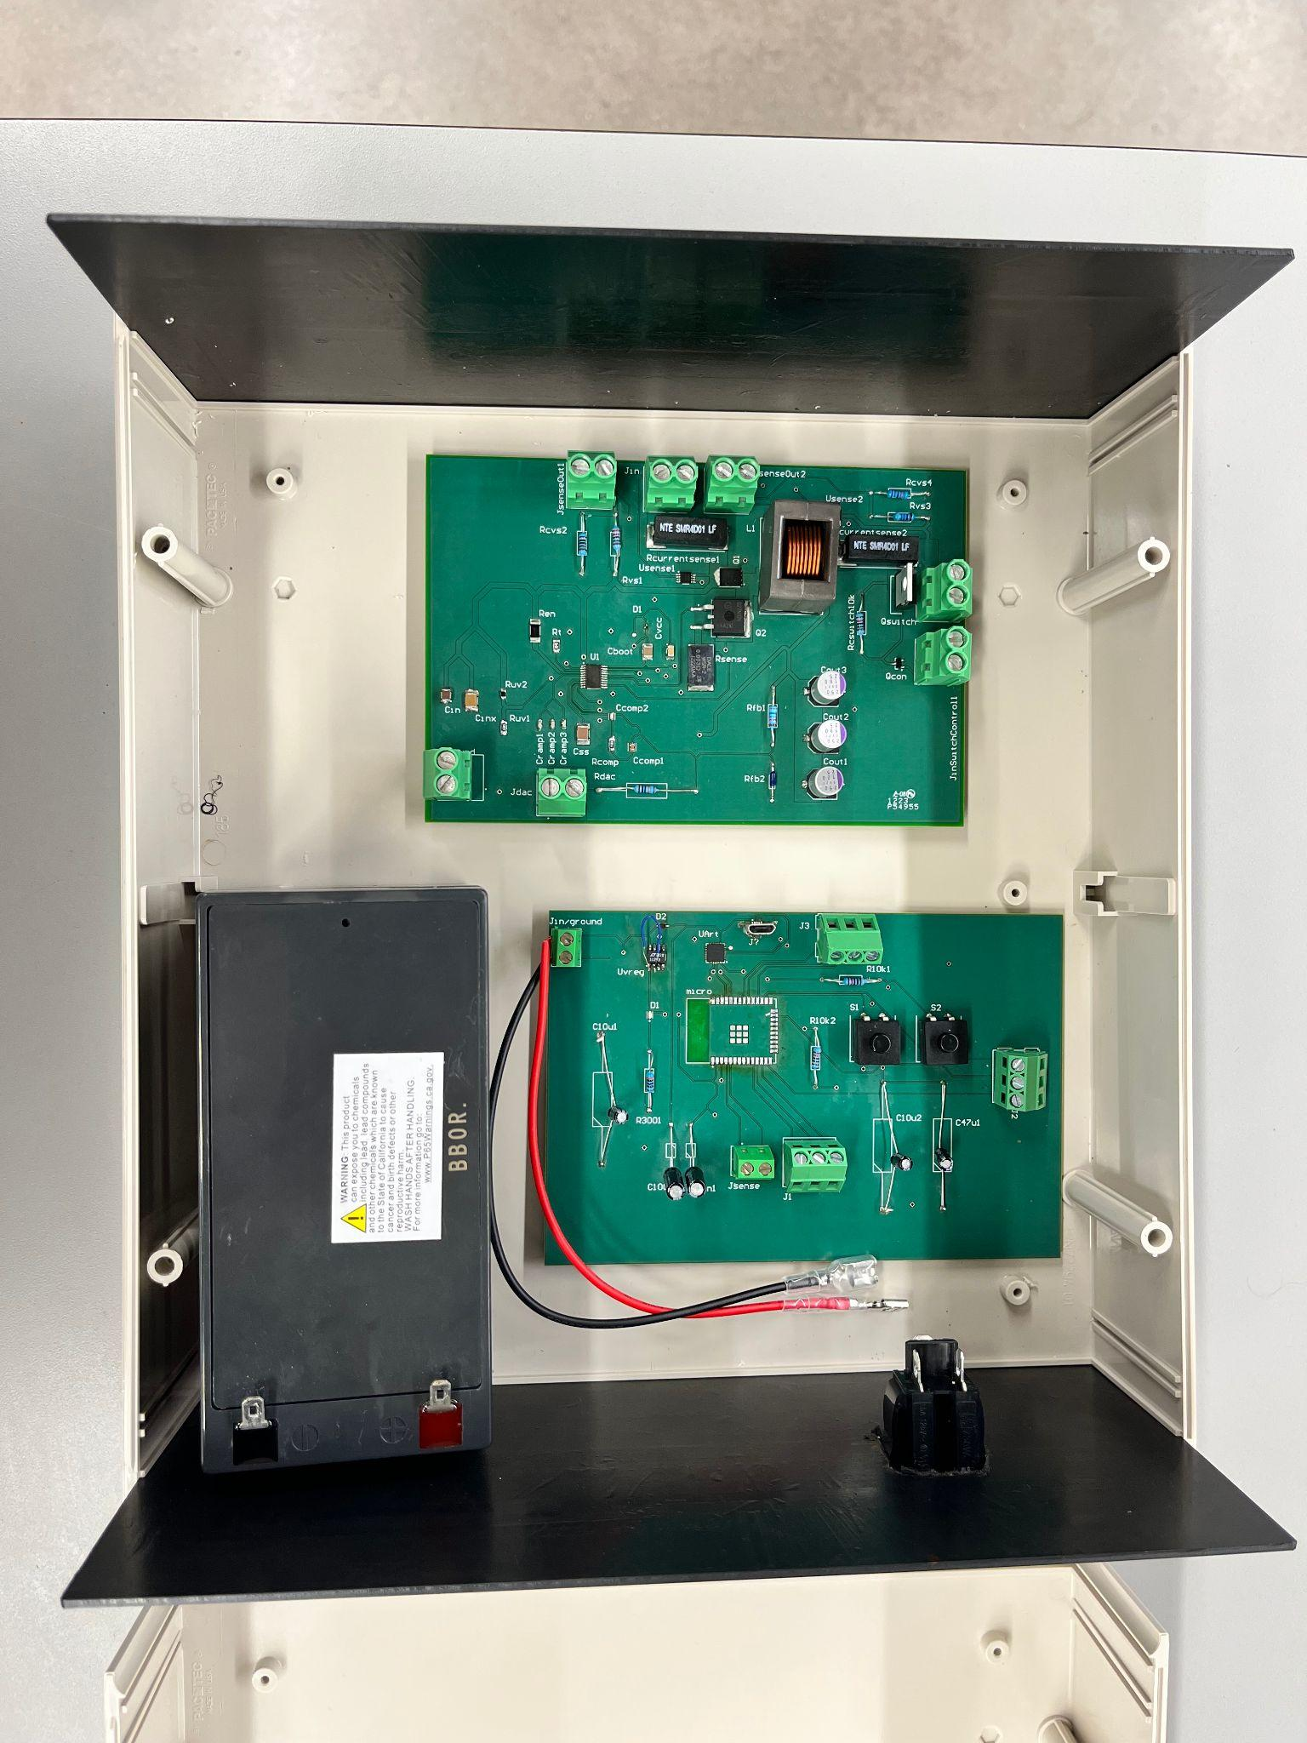

***Figure 3.8: bottom Level of the Enclosure***

***6. Subsystem Diagnostic***

***6.1. 403 Subsystem Diagnostic***

The DC-DC subsystem did encounter some issues during testing and validation. One problem that was encountered and quickly resolved was that the solar panel was not producing enough current for the system to work properly indoors. This seems obvious in retrospect, but the solar panel was producing 30-50V at the same time which led me to believe that enough current was supplied. This was quickly resolved by taking the solar panel outside and/or using the high current power supply in the FEDC.

The most obvious one is that the feedback system does not change the output voltage at all. As the feedback voltage was varied from 1.3 to 4.7 volts there was almost no change in the output voltage.

The other problem came about in the load current testing. The subsystem worked as intended from 0 amp load current until 8 amp load current when suddenly I noticed one of my traces on my pcb was burning. This is why the Output voltage vs Output current test only ranges from 0A to 9A instead of the full load range of 10A as I was not able to test any higher. The proposed solution to this problem is mentioned below in the subsystem resolution/mitigation section. Other than these problems, the system works fully as intended.

***6.2. 403 Solutions***

For the feedback problem mentioned above, an extra diode was removed that solved the problem. The Rdac resistor was also replaced with an 18 kOhm resistor to ensure proper feedback.The burning trace problem was fixed by enlarging the traces past the needed trace width. This ensured that the traces would not burn under any circumstances and that the unintegrated subsystem worked as intended.

***6.2. 404 Diagnostic***

The DC-DC Converter subsystem is able to supply a stable 12V to both the DC-AC subsystem, the DC port, and the microcontroller subsystem while sending voltage and current data to the microcontroller subsystem while running off a variable input voltage, although there are some problems. The most obvious is that when the system is connected to a load larger than 3A, the main mosfet on the switch becomes hot. This issue prevents the subsystem from supplying 12V, 10A power as it was designed to do, only 12V, 3A. While not a problem, something that was noticed was that as the input voltage was raised, the switch had less and less of an effect on the output voltage, while the current response remained the same. Due to the fact that the current still remained 0A no matter what the voltage was shows that this has no effect on the functionality of the DC-DC converter subsystem.

***6.1. Future Work***

If given more time and budget to continue working on the DC-DC converter subsystem, I would like to redesign the PCB such that the terminal ports were placed in a more system friendly way. I would also implement some space between the ports to avoid accidental short circuiting. Figuring out the hot switch mosfet problem would remain the number one priority as it is the only reason the subsystem cannot supply 12V, 10A.

***7. Subsystem Conclusion***

The DC-DC converter subsystem was successfully designed to take a varying input voltage of 20-60V and turn it into 12V stable output for 0A to 10A to supply the rest of the system power and charge DC devices. The output voltage can be adjusted via the control voltage, and the subsystem can be disconnected via a switch signal. This subsystem was tested to ensure proper operation and validated to make sure that it is safe to use with the other subsystems. I personally have learned a lot from this project. Most notably, I learned how to use Altium proficiently. I learned a variety of ways to debug circuits and new tips and tricks to go along with that. I learned how to use lab equipment such as a multimeter, the DC supplies, and the oscilloscope much more proficiently. More conceptually, I learned how to manage my time much better by finding a way to force as many hours in the lab as I could. I learned that things will fail, and it is our job as engineers to come up with a solution, learn from the last mistake, and test the whole thing again.

Solar/Battery Power System

Clement Ong

**DC-AC Inverter Subsystem Results**

Final Draft

25th April 2023

***1. Introduction***

The DC-AC Inverter subsystem is designed to produce a pure sine wave AC output that is nearly identical to the United States electrical grid of 115VAC at 60Hz. It will be powered by the solar panel which feeds into the inverter subsystem via the DC-DC converter subsystem and will be able to charge common electrical devices. The DC-AC inverter subsystem was tested to verify its reliability and efficiency, and that the output was nearly identical to that of the electrical grid and capable of charging the intended electrical devices.

***2. Design***

The inverter subsystem takes in 12VDC and produces 115VAC, capable of charging small electronic devices. It is made up of three main sections: MCU, H-bridge, and transformer. The MCU is programmed to produce PWM and act as inputs to the two MOSFET drivers which will drive the H-bridge. The H-bridge will carry out the inverting process which is connected to a step up transformer, stepping up the voltage to be able to output enough power to charge the necessary electrical devices. Many other components including capacitors, resistors, and diodes were also necessary to carry out the design. The schematic diagram designed through Altium is shown below.

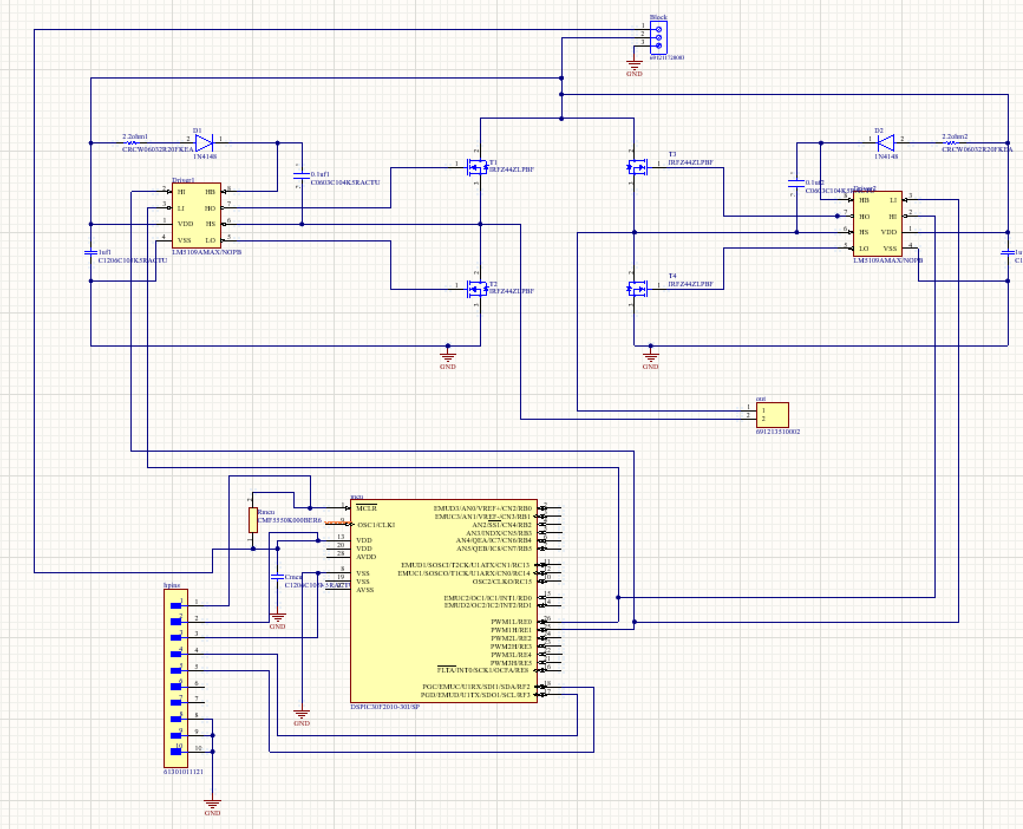

**Figure 1.** DC-AC Inverter Schematic

***2.1. Pulse Width Modulation***

The dsPIC30F2010 is used in this subsystem to produce PWM. This MCU is a 16-bit digital signal controller produced by Microchip consisting of 28 pins, the chip pinout is included below.

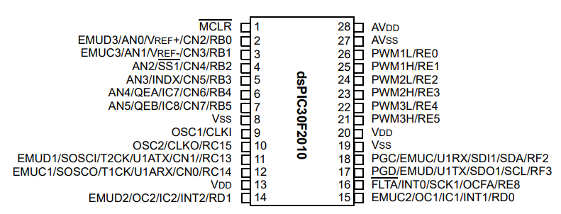

**Figure 2.** dsPIC30F2010 Pinout

Pins 23, 24, 25, and 26 (PWM2H, PWM2L, PWM1H, PWM1L) are set as outputs, as they will hence act as inputs to the two MOSFET drivers as shown in **Figure 2**. The high outputs of the MCU will output square waves with changing duty cycles to resemble a pure sine wave. The low outputs will output the same waves as the high outputs, except they will be shifted by 180 degrees, essentially creating an inversion of each other. Pins 8 and 13 (Vdd and Vss) will also be used for positive supply and ground reference, respectively.

MPLAB X IDE is used to code the MCU using C language, and a PICKIT3 will be used to program the chip.

A sine table made up of 512 values is constructed using excel to create the proper PWM needed to generate the final expected output of a pure sine wave. The points are obtained using equationsbelow.

$Point 'x' =(2π*x) / 512$***Equation 1***

Where ‘x’ is the nth point from 0 to 512 that will be used to construct the sine table.

Using the points obtained by **Equation 1**, the sine table is then constructed with the formula below.

$Sine Table Point 'y' = (sin(point 'x') + 1) * 75 / 2$***Equation 2***

Where ‘y’ is the nth point of the sine table from 0 to 512.

Below is a scatter plot of the sine table, graphing each ‘y’ point from the equations, showing a pure sine wave that goes from 0 to 65535 (max value) where the x-axis is the time step and the y-axis is the duty cycle.

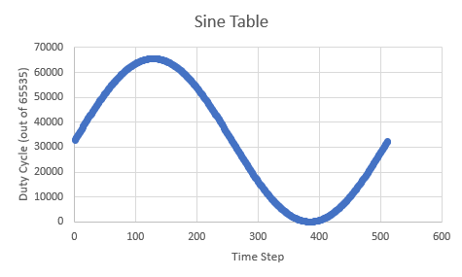

**Figure 3.** Sine Table Plot

A function ‘configure_pins’ is created to configure the MCU pins and PWM for free running mode. The PWM period was calculated as follows:

$PWM Period = Tcy *Prescale * PTPER$***Equation 3***

where Tcy is the clock cycle set to 0.33ns, Prescale is set to 4, PTPER is the Time Base Period set to 7576, resulting in a PWM Period of 40us. From this, the PWM frequency was calculated using the following formula:

$PWM Frequency = 1/T$***Equation 4***

where T is the PWM Period of 40us, resulting in a PWM frequency of 25kHz which is compatible with the selected MOSFET drivers for this subsystem.

This means that each pulse will be of 40us of different duty cycles, and after the 512 value square wave, total time will be 20ms which is a 60HZ required frequency of the sinusoidal PWM.

A deadband gap was also implemented as protection to the entire system. This deadband gap ensures safety as it can help avoid unnecessary switching of the inverter, increasing efficiency and longevity of the system. After testing, it was found that a deadtime value of 7 was the best for this system. The deadband gap in the PWM wave as mentioned is shown below.

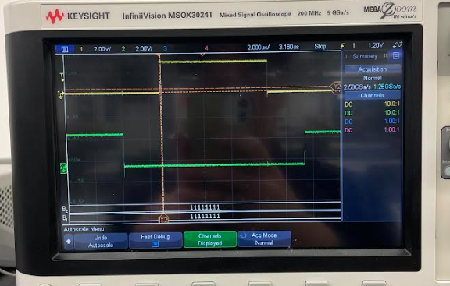

**Figure 4.** Deadtime gap, High Output (yellow), Low Output (green)

The output of this MCU shall be a square wave with increasing and decreasing duty cycles where, when plotted, the duty cycle shall resemble a sine wave as shown in **Figure 3**. The code used to generate the PWM for this subsystem is below.

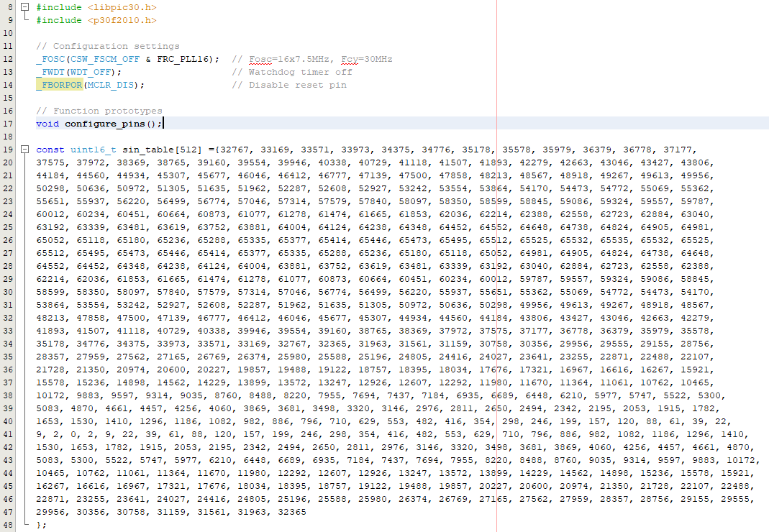

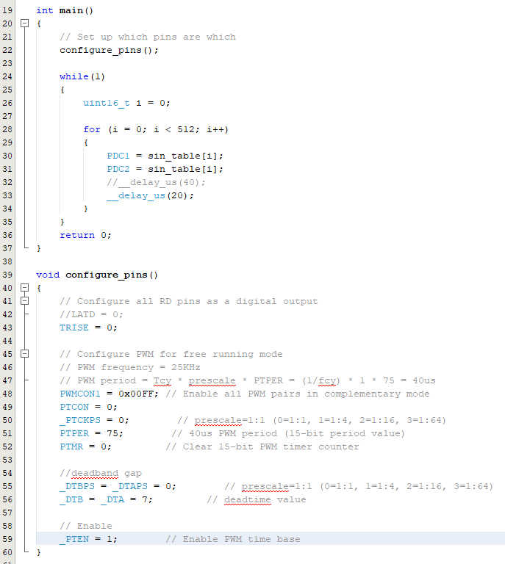

**Figure 5.** PWM Code

The final PWM output waves produced by the MCU are shown below. As seen in the figures, the duty cycle constantly changes, producing a pure sine wave that oscillates at around 60Hz.

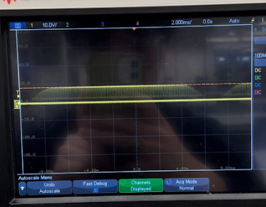

**Figure 6.** PWM wave (zoomed out), High Output

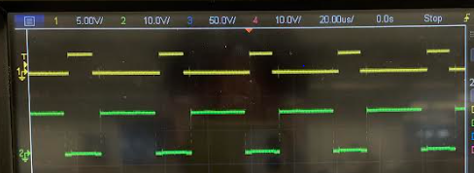

**Figure 7.** PWM wave (zoomed in), High Output (yellow), Low Output (green)

With a simple RC filter implemented at the output of the MCU, the output of the MCU PWM is shown below, resembling a sine wave.

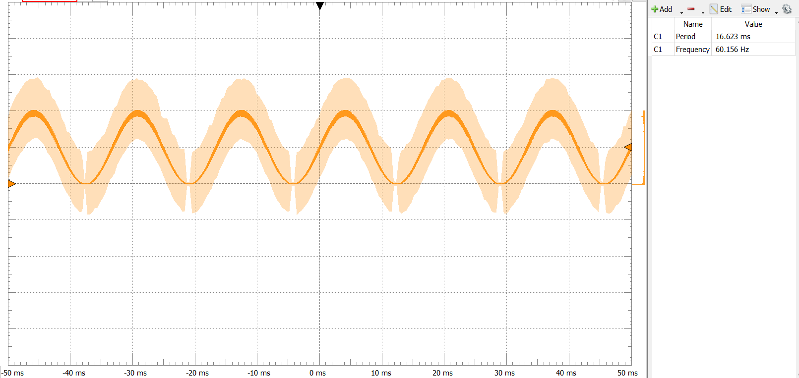

**Figure 8.** PWM wave with RC filter

***2.2. H-Bridge***

A single phase H-bridge was designed using two MOSFET drivers and four PMOS MOSFETs. The LM5109AMAX/NOPB MOSFET drivers were selected for this subsystem and are compatible with the PWM frequency generated from the MCU. Bootstrap capacitors, bootstrap resistors, and bootstrap diodes were also included in the design to ensure driver functionality and protection as per the datasheet. The high input and low input pins will take in square waves from the MCU as described in section **4.2.1.** These drivers will drive the gate driver of the power MOSFETs.

The high outputs and low outputs of the drivers are connected to the gate of the MOSFETs. The MOSFETs used in this subsystem are the IRFZ44ZLPBF MOSFETs. This connection of the drivers and MOSFETs will essentially create the inverting mechanism that will result in the expected pure sine wave similar to that of the U.S. electrical grid.

***2.3. Step-Up Transformer***

The output of the H-Bridge section is connected to a step-up transformer which will step up the 12VAC to 115VAC. The DP-241-9-12, a 1:9.58 turn ratio transformer, is used for this system.

***2.4. PCB Design***

The PCB design for this subsystem was designed using Altium designer and shown below. It consists of 20 components, two layers, a bottom layer and a top layer, and a polygon pour that was used to create the ground plane.

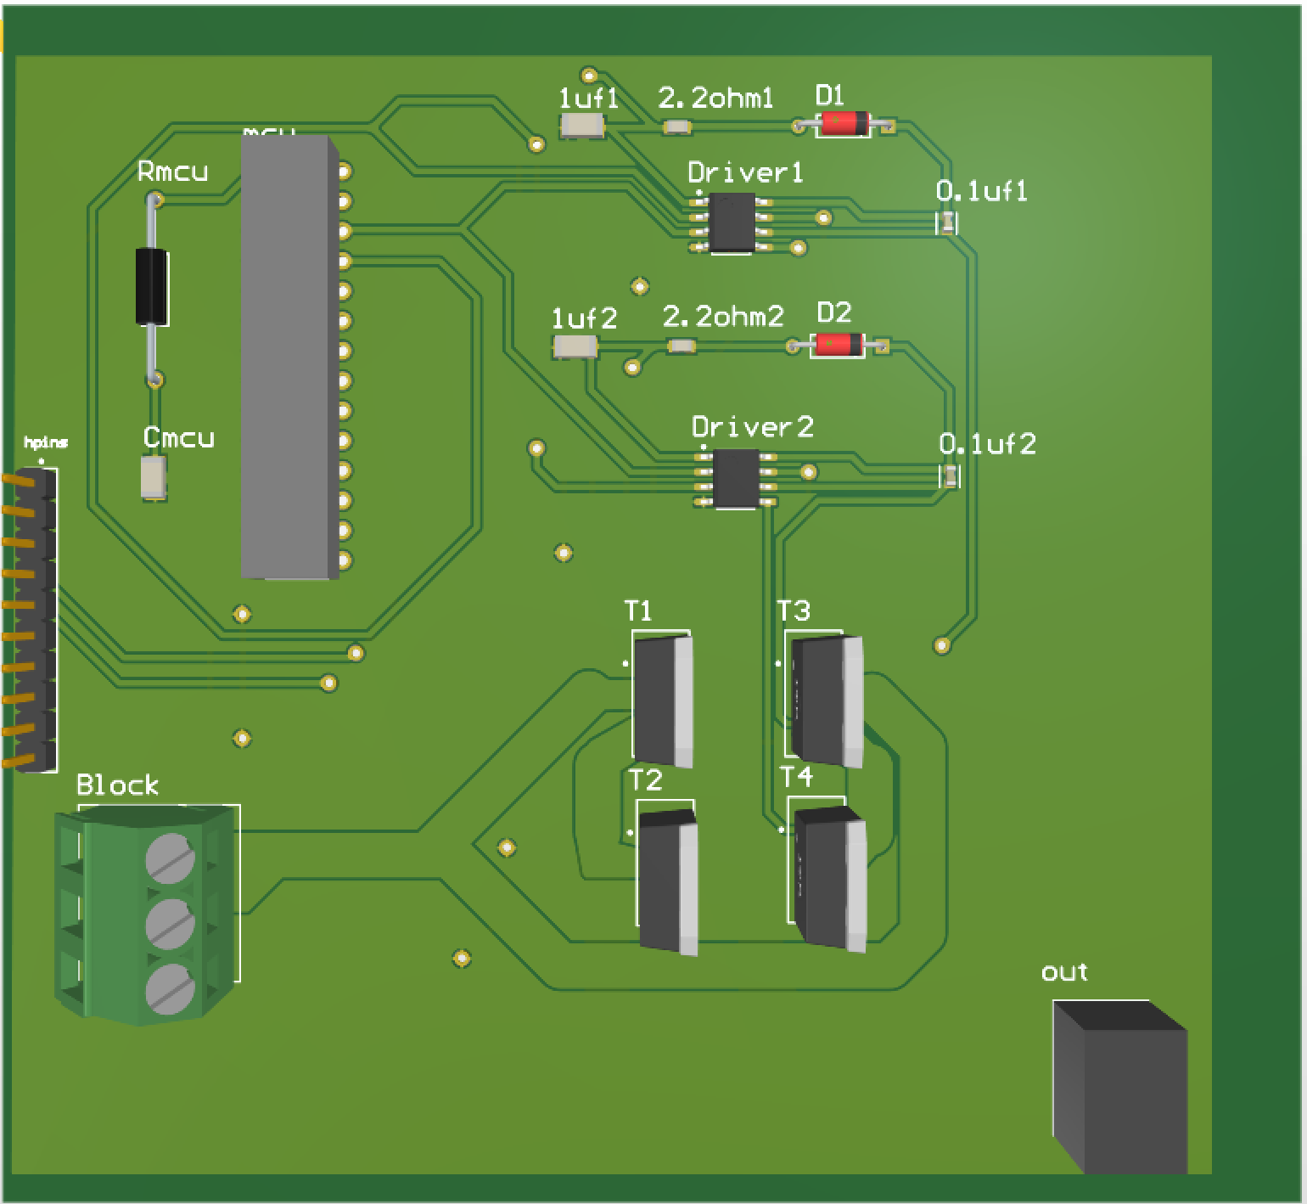

**Figure 9.** PCB Design

***3. Subsystem Validation***

The circuit was initially built and tested on a perfboard as shown in the figure below. The MCU was placed on a breadboard, powered by the Pickit3, and connected to the H-bridge that was soldered onto the perfboard.

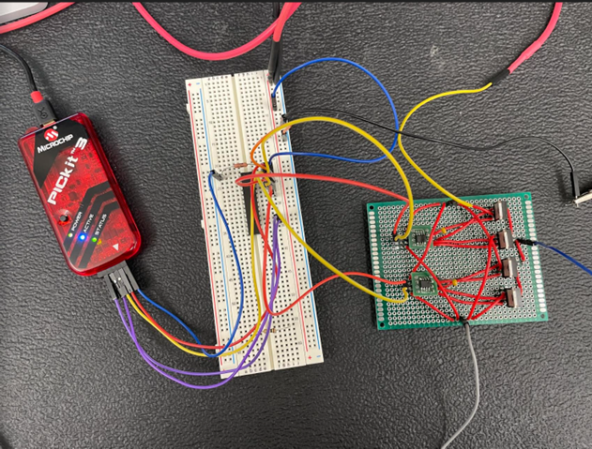

**Figure 10.** Inverter PerfBoard

Initial testings carried out on the PerfBoard were successful. The system was then tested on a circuit board. The final circuit board for the inverter is below. 3.3V was used to power the MCU, and 12V was used to power both the drivers and the MOSFETs.

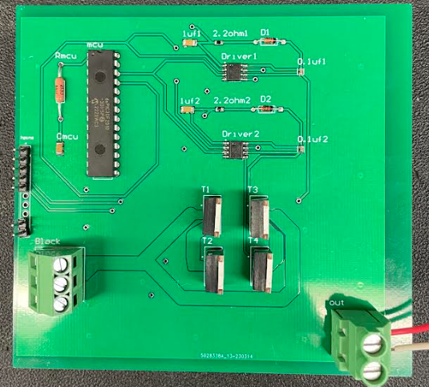

**Figure 11.** Inverter Circuit Board

The circuit board was first tested without the transformer and the load connected. The waves at the MCU, driver, and output were tested and validated, as indicated by the figure below. The high output of the MCU is in yellow, the low output of the driver is in green, the high output of the driver is in blue, and the system output of one side is in purple. The waves produced at each of these nodes were all as expected.

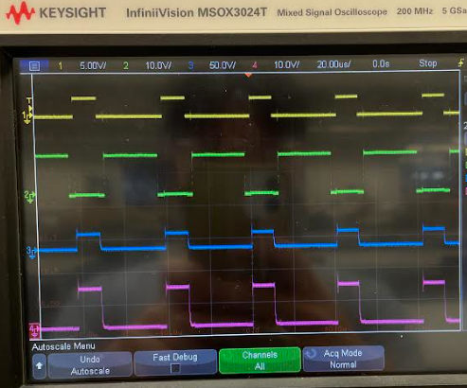

**Figure 12.** Circuit Board Nodal Outputs

With the transformer connected, the output waves were very similar. The results of the inverter system, with and without the transformer, are shown in the table below, using a multimeter to collect the data.

| **Specification (Input: 12V, 1A)** | **Result** |
| --- | --- |
| Output frequency (Hz) | 60.156 |
| Output AC voltage without transformer (V) | 10.415 |
| Output AC voltage with transformer (V) | 108.78 |
| Output AC current with transformer (A) | 0.0745 |
| Output power (W) | 8.104 |

**Table 1.** Inverter System Results

An LED light bulb and a portable charger were both used to test the system’s functionality. Both devices were successfully powered by the inverter system. The light bulb was able to be turned on, and the portable charger was able to be charged.

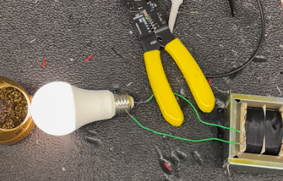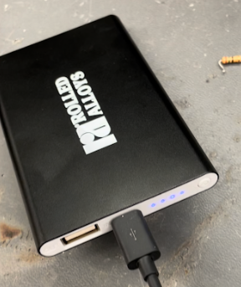

**Figure 13.** Inverter system test with light bulb (left) and portable charger (right)

***4. Subsystem Mitigations and Improvements***

The DC-AC inverter system is able to output an AC signal that is very close to that of the U.S. power grid. Though, power loss was one of the biggest problems with this system. It was not successfully able to step up 12VDC to 115VAC, as it only reached a maximum of 108.78VAC, and there was large amounts of current loss throughout the system which yielded a lower power output as intended. If more time and money was allotted, many design changes could be implemented to reduce the amount of power loss within the system. Another H-bridge could be incorporated, higher quality components could be used, and many other factors could be more carefully considered to all maximize the power output of the system. Furthermore, the final output waveform of the system could not be obtained as high voltage oscilloscope probes were not accessible during testing, though, an RC filter could have been implemented at the output of the transformer to filter out any extra noise to create a smoother sine wave, increasing system efficiency.

***5. Subsystem Conclusion***

The DC-AC Inverter subsystem was designed to take in 12VDC, convert it to 12VAC that is nearly identical to the United States electrical grid, and stepped up by a step-up transformer to successfully power common electronic devices. It was designed using a MCU to provide PWM, an H-Bridge design for the inverting mechanism, and a step-up transformer.

The system was tested and validated thoroughly to meet certain requirements. Though there are still many constraints and limitations regarding this system, the system successfully outputs AC electricity and is proven to be capable of powering smaller electronic devices.

Solar/Battery Power System

Nathan Gil

**Website and Android Application Subsystem**

Final Draft

25th April 2023

**5. Android Application and Website**

***5.1. Subsystem Introduction***

The Android Application and Website subsystem is designed to provide the user with information on the solar panel battery system that could be used for maintenance and analysis. This system was made using Ionic with Angular allowing for both the website and application to be designed concurrently. Both applications also use a backend database, firebase, to send and receive data that the user needs about their system. The data that is displayed by both applications is the solar panel power, current, voltage, battery level, battery discharge, battery charge, and the current weather conditions in a city provided by the user. The power is displayed in a graph, showing real time data from that current day depending on the harnessing of the system. This data also is being tracked on a weekly basis. To provide security for the user, an authentication page is implemented on both applications forcing the user to be validated in order to access specific user data.

It should be noted that there are no code snippets inside this report. All code is shown in our TAMU repository for this project:

<https://github.com/nateg580/SolarBatteryWebsiteAndriodCode.git>

To navigate this repository, go to “src” then “app”. This will take you to the actual code that was used to implement the android and website applications. Additionally, I did want to note that I also helped Lauren with her ESP-32 communication with the backend database. The only file that I created using “c” was the send_data.c file. This file sent and updated data from the ESP-32 to the backend. The link for this repository is also shown below, to navigate to the file that I created, click on the “master” branch located to the left, then navigate to “nathanBranch”. Then navigate to the “main'' folder, and inside that send_data.c can be found.

<https://github.com/llugo15/solar_power.git>

***5.2. Subsystem Design***

At a high level, the design of this subsystem was for both applications to send and extract data from the backend database in the most efficient manner. To accomplish this, the backend database had to be structured so that data that comes in is set into categories, making it easier for the frontend (what is seen by the user) to retrieve data. To organize data in the backend in categories, a tree was used. At the highest level of the tree is the description of the data that shall be extracted, for example, the current user, “nate@gmail”. Additionally, there is a “preferences” tab at the highest level hosting the current user’s preferences (name of system and city location). Inside the tree is the data that shall be specifically pulled, such as the battery level or the solar panel and battery current and voltage values. This design is shown in **Figure 5.1.**

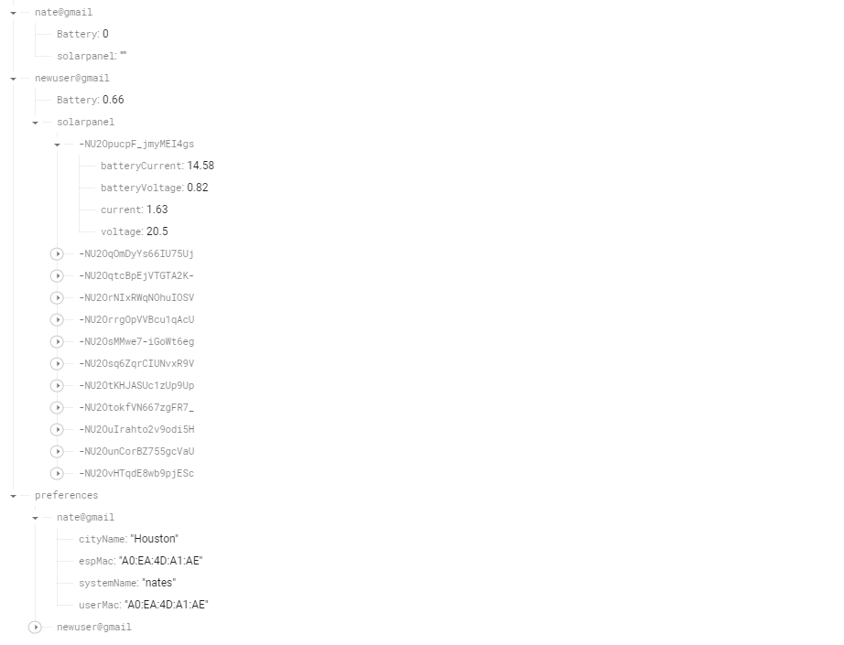

***Figure 5.2.1.*** *Tree Structure used in Firebase Database*

At a lower level, the design of both applications differed. A beginning template is shown in **Figure 5.2** for the initial website design, and **Figure 5.3** for the initial android application**.**

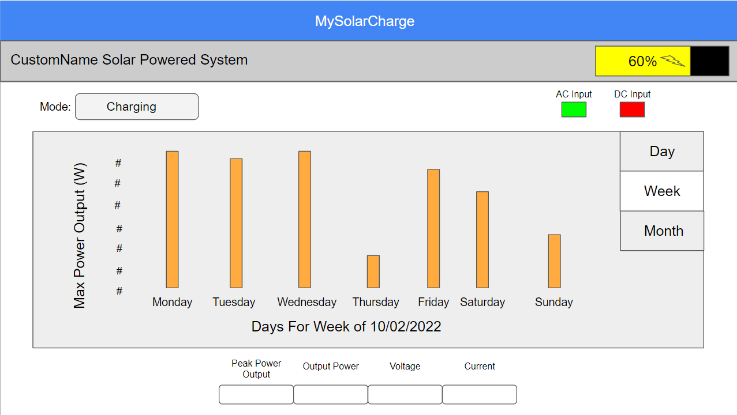

***Figure 5.2.2.*** *Initial Design of Website Application*

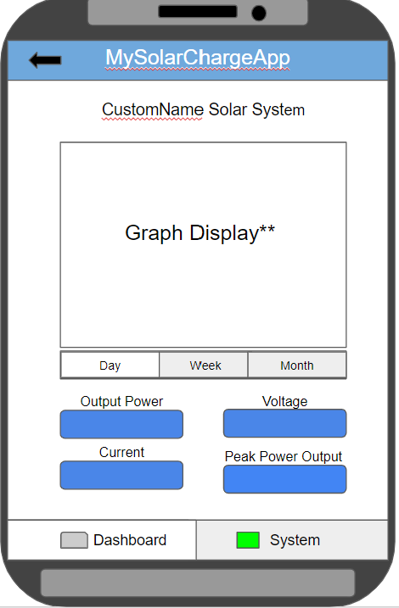

***Figure 5.2.3.*** *Initial Design of Android Application*

The website application was made using only one page. This means there are no other pages or tabs that can be accessed on the website other than the authentication page. All the data is then displayed on this page, giving the user the ability to change the graph views to see the current day and week data. The reason for this design approach was to give the user easy access to all the data without having to separate it on multiple pages. Additionally, there were not enough different types of data that could be used for another page. As for the android application, the design was to have the current day and week graph data on the first page so the user knows instantly how their system performs in real time. There is then another page that the user can access to look at the current weather for the city they are in. This is to add separation and decrease the clutter of data that is displayed to the user since a phone has a smaller screen size then a laptop or desktop. Hence the need for two different designs which make both applications more user friendly. It should be noted that both applications display the same data to the user. At the top of both applications is the app name and the ability to name the system that the application is connected to. There is also the ability to log out of the current user which is automatically toggled if the user is signed onto the app for longer than an hour. This provides security and battery life saving for the user's device. Under that displays the battery level, if the battery is charging or discharging, the power produced, the power imported from the battery, the battery voltage discharge and charge amounts, the active current, and the active voltage throughout the system. Then a graph is displayed, showing the power data for that day, with an option to view the current week data, which are accessed through a button at the bottom of the graph. Lastly, the weather is displayed to the right of the power graph (on website) and on the weather tab (on the android app). The final design is shown in **Figure 5.4 and 5.5** for the Website Application and **Figure 5.6 and 5.7** for the Android Application.

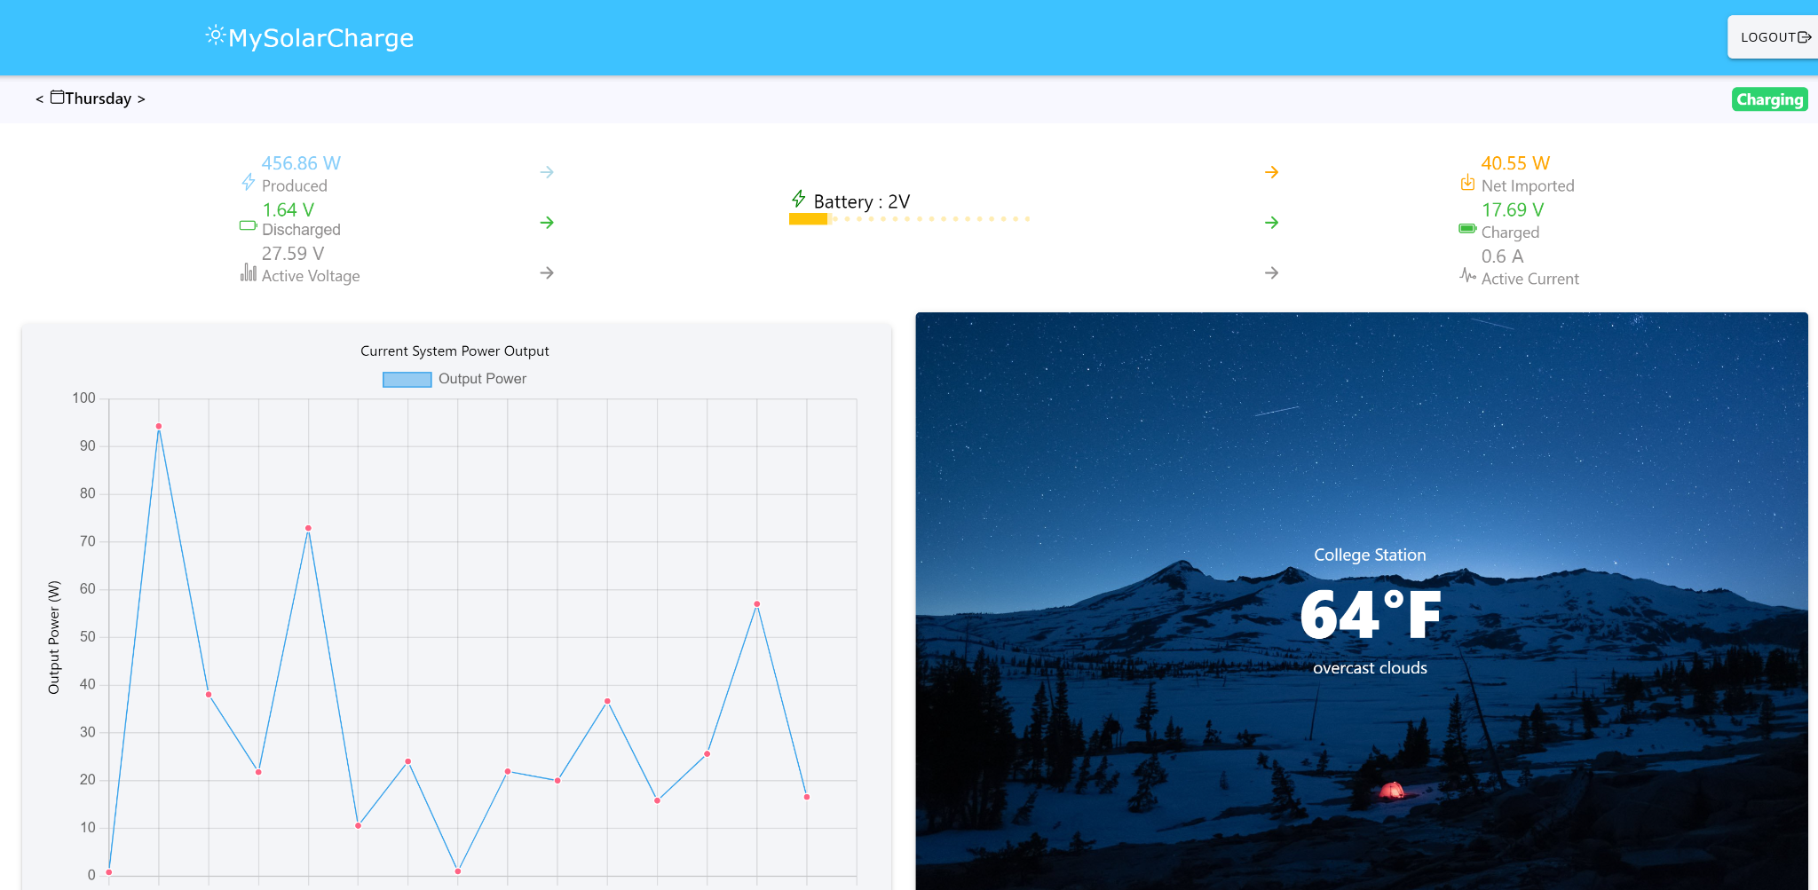

***Figure 5.2.4.*** *Final Design of Website Application*

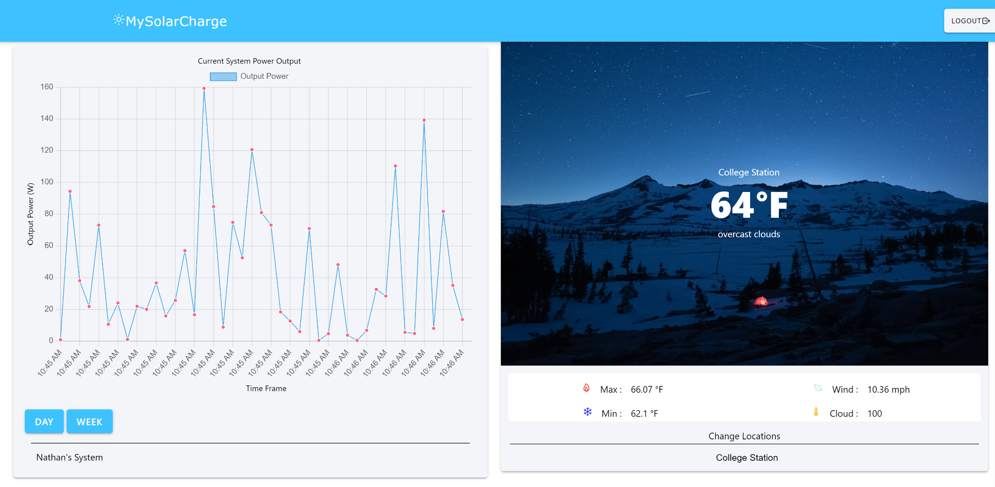

***Figure 5.2.5.*** *Final Design of Website Application showing Full Visual of Power and Weather*

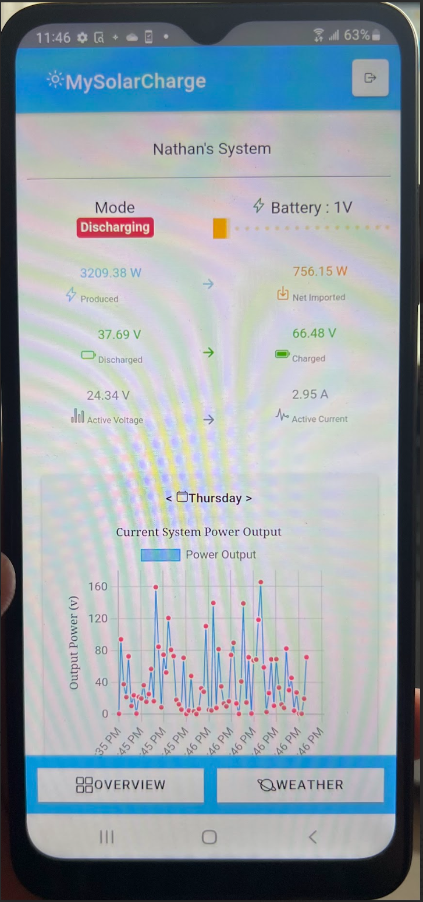

***Figure 5.2.6.*** *Final Design of Android Application Overview Tab*

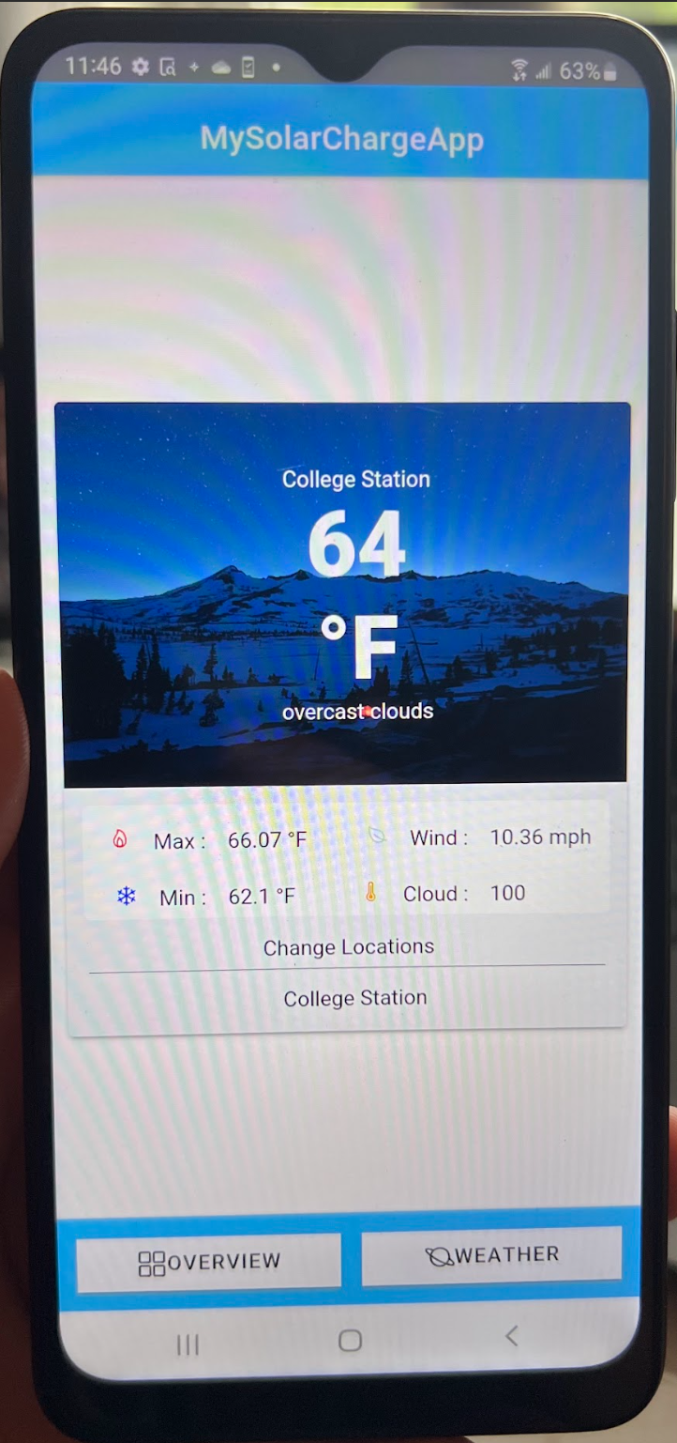

***Figure 5.2.7.*** *Final Design of Android Application Weather Tab*

***5.3. Subsystem Validation***

***5.3.1. Data Output***

This subsystem shall show data that is received from the backend on the website and android application for the view to see. The data should be organized in a user friendly manner, embodying stylistic eye catching components. This validation is important for software engineers. The way data is displayed to the user is crucial for re-usability and user satisfaction.



***Figure 5.3.1.1.*** *User Friendly Interface for Website Application*

**

***Figure 5.3.1.2.*** *User Friendly Interface for Android Application*

***5.3.2. Diagnostic Output***

This subsystem needs to receive data from the backend database dynamically for the graphs and data displayed to the user updates in real time. To test this, one test case was written that executes each time new data enters the application from the database. As shown in the figure, this test case is TEST4, fetching the current battery level.

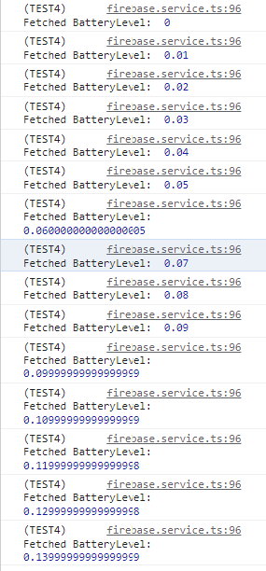

***Figure 5.3.2.1.*** *Applications Receiving Data from Firebase Database Dynamically*

***5.3.3. Website and Application Pull Request***

The website and application shall successfully pull data from the firebase database without interruption. If the pull request is not properly configured or coded, the http request from the front-end can be unsuccessful, causing the front end to display no data and receive an error code from the database. The figure below shows all the data that is being pulled successfully.

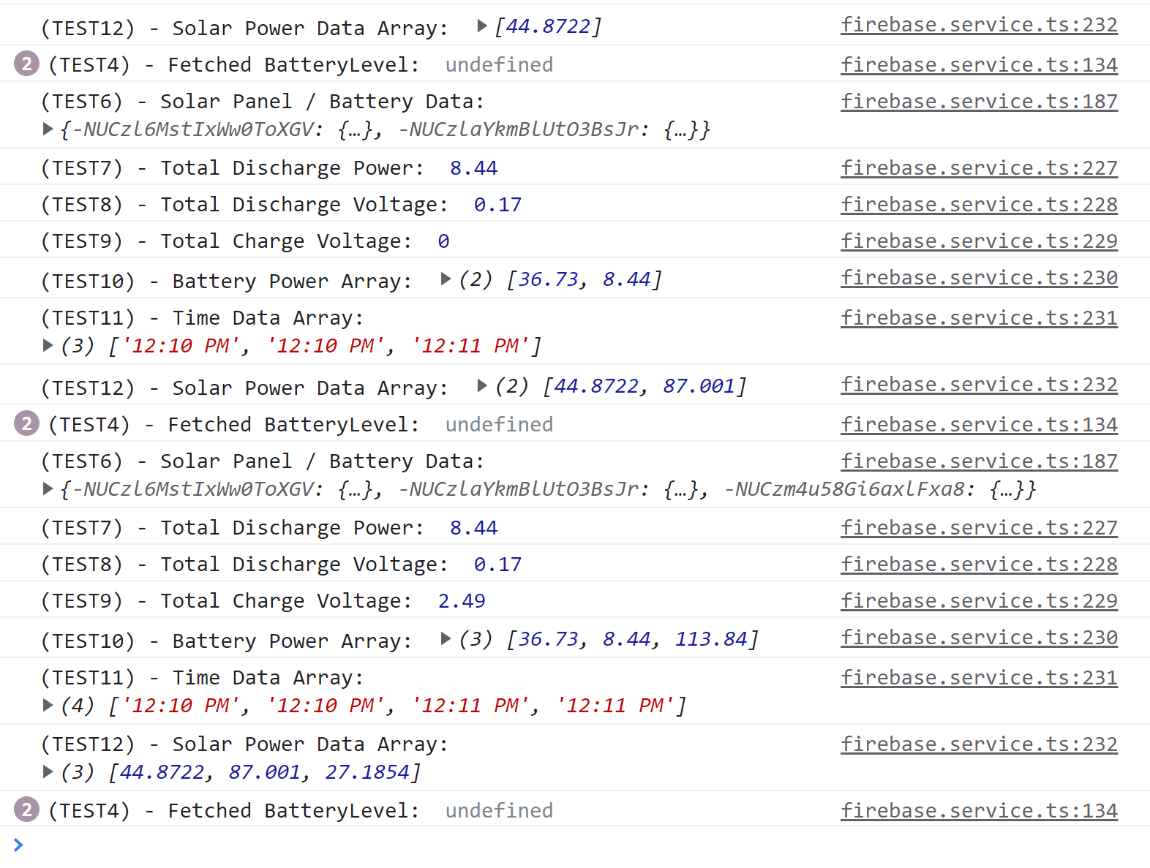

***Figure 5.3.3.1.*** *Http Successful Pull Request without Errors*

***5.3.5. Back-End from ESP-32 Communication***

The firebase database shall successfully receive data from the ESP-32 without interruption. The ESP-32 is the device inside the system that is gathering the solar panel and battery voltage and current data. Sending data from the ESP-32 results in an HTTP error request thus, getting the internal system data is crucial for the front-end display. This will be shown through the VScode terminal, when the ESP-32 connects to the internet it will send data to the backend in a JSON format.



***Figure 5.2.5.1*** *ESP-32 Sending Data from Local Laptop*

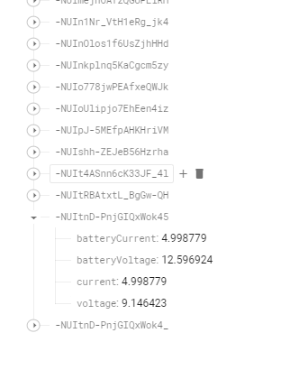

***Figure 5.2.5.2.*** *Backend Database Receiving Data from ESP-32*

***5.3.6. Front-End From ESP-32 Communication***

The website and android application shall receive data from the backend firebase database which received its data from the ESP32 successfully. This two-way communication is how the user sees data from within their solar panel system. To validate this, a screenshot will be shown of data from the ESP-32 sent to the backend, and that data being displayed to the front-end.

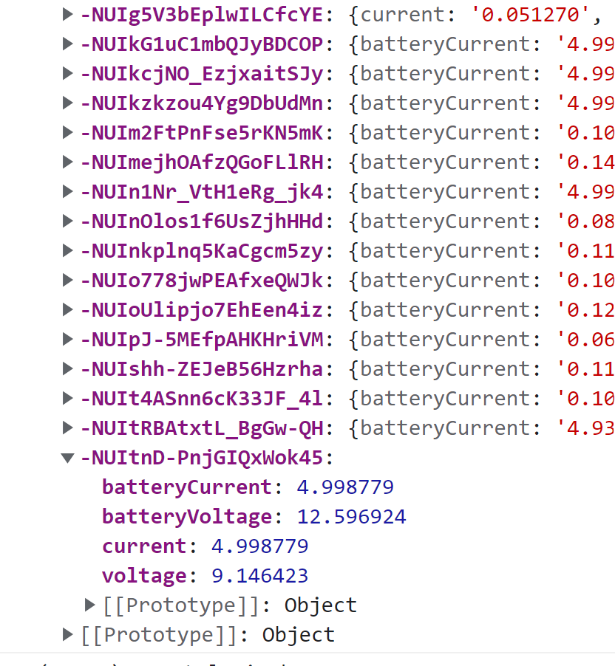

***Figure 5.2.6.1.*** *Front-End Receiving Data from ESP-32 via Database*

***5.3.3. Physical Requirements***

When coding a website and android application simultaneously, the webpage allows you to view what the application would look like on a virtual device. This structure shall transfer over onto a physical device without stylistic errors and response time errors. A picture of the angular-ionic application is shown on the android app successfully in **Figures 5.5 and 5.6.**

***5.3.4. User Authentication***

This subsystem includes a user authentication page. The authentication page gives the user the ability to sign up a new account along with signing into an existing account. Signing up for an account is allowed as long as the password is above six characters and there is not a current user that has the same email address as the one being used to sign up. These validation tests are shown in **Figure 5.9 and 5.10** respectively.

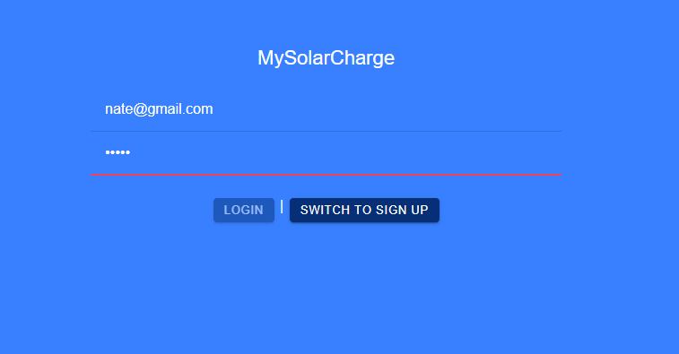

***Figure 5.9.*** *Authentication Page Showing Minimum Six Character Password Limit*

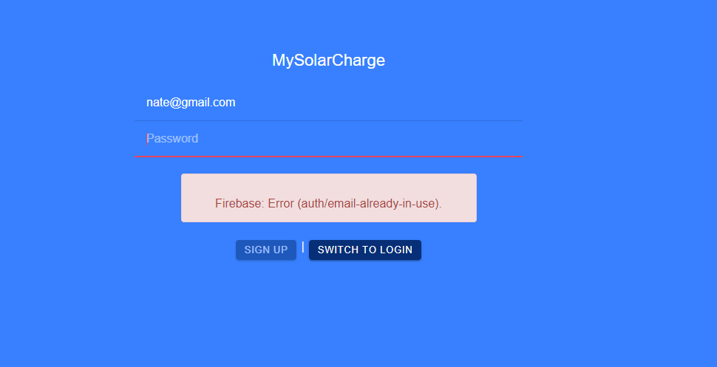

***Figure 5.10.*** *Authentication Page Showing Existing User Email Error*

***5.3.5. Existing User Authentication***

This subsystem includes a user authentication page. The validation for signing into an existing account is the correct password and checking if a user has an existing account, these validations are shown in **Figure 5.11 and 5.12** respectively.

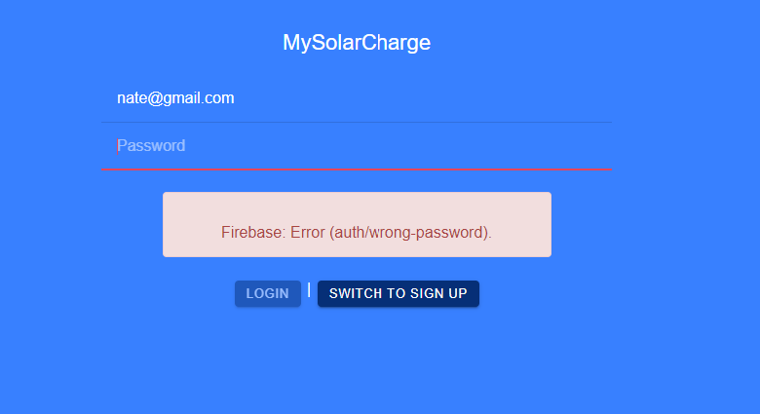

***Figure 5.11.*** *Authentication Page Showing Incorrect Password Error*

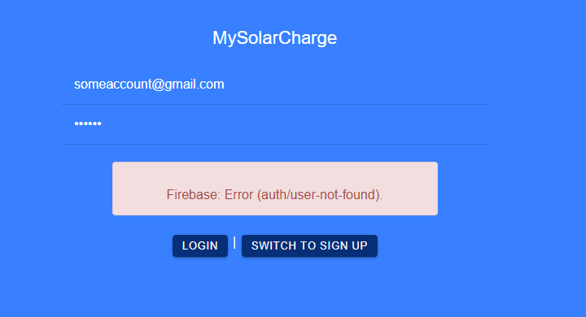

***Figure 5.12.*** *Authentication Page Showing User Not Found Error*

***5.4. Subsystem Diagnostic***

This subsystem checked off all the validation and execution planning that was set forth. The system successfully completed the final demo and displayed all the data that was described above accurately and efficiently for the user. This subsystem is completely set up in regards to sending data to the database from the ESP-32, receiving that same data from the database in both applications, and displaying the data for the user. It should be noted that a weather feature was not originally in the initial design in 403. This feature was added this semester for the user's convenience of knowing what the weather is without having to exit out of the application and onto their local weather app. Providing this functionality adds onto the user experience and satisfaction for the application, and goes beyond the scope of the sponsor's initial requirements.

***5.6. Subsystem Conclusion***

In conclusion, 403 and 404 taught me a lot. There are two things as a student and engineer that developed further, my technical skills with website and app development, and team leading skills. For technical skills, before this class I already knew how to create websites using AngularJS. What is different about this project was the addition of the android application. With this addition, I had to learn how to concurrently create a website and app at the same time with a year deadline. This led me to using and learning Ionic View, which is an add on to Angular JS that allows the user to design a website and app concurrently. It does this by adding static components that are compatible with both applications. Additionally, my backend database skills were brushed up as I tried multiple structures on how to organize data in the backend. It was noted that a linear, or more flat way of organizing data was the best from extracting information in a timely manner. Furthermore, I learned how to use, replicated the environment, and code and ESP-32. The purpose of this was to help my other project member, Lauren, expedite her process of sending data to the backend. Learning how to do this is crucial since most boards or components use ‘c’ code to program their functionality.

As from team leading skills, I learned that to keep a team on track means two things, encouragement, and persistence. Being the team leader led me to keep the environment of the team “casual”. What that means is that every idea was accepted and there was never a moment where each team member felt like they could not rely on one another. This leads to excellent communication and understanding of the common goal. Persistence was the other key factor, this project is a year long, and we all have classes that we are focusing on while making this project. Making sure that everyone is finishing their papers and staying on a schedule was crucial for our success throughout both semesters. More than creating the independent solar system, this class was about learning, but most importantly failing.

Solar/Battery Power System

Clement Ong

Tarik Dawson

Lauren Lugo

Nathan Gil

**System Description and Development**

Final Draft

25th April 2023

**Table of Contents**

**Table of Contents** **99**

**List of Tables** **100**

**List of Figures** **101**

[**1.** **Overview**](https://docs.google.com/document/d/1oE2DfG66k3oLzQfO3jbMR8eg0nUGLV6A/edit#heading=h.1t3h5sf) **102**

**2.** **Development Plan and Execution**  **102**

2.1. Design 102

2.2. Execution 103

2.3. Validation 105

**3.** **System Data 108**

3.1. DC and AC Data109

3.2. Sensor and Switch Data 109

3.3. Applications Data 110

**4.** **Conclusion 111**

4.1. Learnings 112

4.2. Future Work 112

**List of Tables**

**Table 1: Full System Data…………………………………………………………………………………109**

**List of Figures**

**Figure 1: Functional System Diagram………………………………………………………………102**

**Figure 2: Full System……………………………………………………………………………………….108**

**Figure 3: ESP-32 Terminal Output…………………….………………………………………………110**

**Figure 4: ESP-32 Sending Data to Database………………………………………………………110**

**Figure 5: Backend Database Receiving ESP-32 Information………………………………111**

**Figure 6: Frontend Receiving Database Information from ESP-32 Dynamically…111**

***1. Overview***

The Solar/Battery Power System is a sustainable and portable way to power both your AC and DC devices anywhere you want. This system contains multiple subsystems including a DC-DC converter, DC-AC inverter, microcontroller, sensors and switches, and a website/application. To ensure a complete product, proper integration and validation was performed to the best of our ability to meet the project requirements.

***2. Development Plan and Execution***

The first semester of capstone was dedicated to researching how the previously mentioned subsystems would work and producing working individual systems to put together later in 404. The second semester of our capstone project saw us fixing previous mistakes on our subsystems, redesigning our subsystems to fit together, and integrating them all together to form one working system.

***2.1. Design Plan***



***Figure 2.1.1.*** *Final Design for Integration of Solar Panel System*

The design plan was the most crucial part of 403 and 404. Once given our problem statement, as a group we broke it down into four different subsystems, the MPPT Microcontroller (with switches), the DC - DC Converter, the DC - AC Inverter, and the Website and Android application. After this division, the next question was which subsystem does all other subsystems rely the most on? For our project, this was the MPPT Microcontroller. The design plan was then to focus on how to input and output from the microcontroller for each subsystem. For the DC - DC Converter, this subsystem was designed to take the solar panel power as its input, and step down to an output of 12 V DC so that the battery and DC output could be powered, along with providing the DC - AC inverter with its subsystem input. This design choice was selected because of the DC output of the solar panel and the different subsystems that needed to be powered by the DC -DC converter. This caused the overall system to be smaller and more efficient in power transfer, providing a consistent voltage throughout the system. The system’s design was to ensure that the DC output would constantly be 12 volts, this meant that if the battery voltage dropped below 10.5 volts without the solar panel to charge it then the whole system would shut down. The reason for this design is because all subsystems need at least 12 volts to run their subsystems properly. This design choice was chosen due to the unreliability of the solar panel output power during the night or whenever there is bad weather. The lack of a DC voltage would not charge a small device and the system would become obsolete.

***2.2. Execution***

To build a full working system, a number of steps had to be taken instead of just mashing subsystems. The first of these steps was to finish our individual subsystems, correcting any problems noticed in 403. We made many improvements to our systems in this time and finished up the rest of the work for our subsystems. The next step was redesigning our subsystems such that they would not burn or collapse any other subsystem. This period was focused mainly on carefully testing all interaction points between each subsystem and how every other subsystem would react to this. The third step was focused on slowly integrating each system together one at a time. Some examples of this include connecting the microcontroller to the database, hooking up the DC-DC converter to the DC-AC inverter, and hooking the voltage and current sensor from the DC-DC converter to the microcontroller. The final step was putting all the subsystems together and running full tests to ensure the system worked as intended. Shown below is our execution plan following these steps.

|  |  |  | | |  |  |  |  |  |  | | | | | | |
| --- | --- | --- | --- | --- | --- | --- | --- | --- | --- | --- | --- | --- | --- | --- | --- | --- |
|  | ***Solar Power Battery*** | | | | **2022** | | | | | | | | | | | |
|  |  |  |  |  | **January/February** | | | | | | **March** | | | | **April** | |
|  | **Deliverable/Task** | | **Responsible** | **Duration** | 1/23 | 1/30 | 2/6 | 2/13 | 2/20 | 2/27 | 3/6 | 3/13 | 3/20 | 3/27 | 4/1 | 4/10 |
|  |  |  |  |  |  |  |  |  |  |  |  |  |  |  |  |  |
|  | **Status Update 1** | | |  |  |  |  |  |  |  |  |  |  |  |  |  |
|  |  | Discuss PCB Breakdown | All | 2 w |  |  |  |  |  |  |  |  |  |  |  |  |
|  |  | Review Subsystems | All | 2 w |  |  |  |  |  |  |  |  |  |  |  |  |
|  |  | Test all sensors and switches | Lauren | 2 w |  |  |  |  |  |  |  |  |  |  |  |  |
|  |  | Connect to wifi | Lauren | 1 w |  |  |  |  |  |  |  |  |  |  |  |  |
|  |  | Make PCB for Sensors and Switches | Tarik | 1 w |  |  |  |  |  |  |  |  |  |  |  |  |
|  |  | Fix Feedback system | Tarik | 1 w |  |  |  |  |  |  |  |  |  |  |  |  |
|  |  | Fix Firebase Backend by Organizing User Data | Nathan | 1 w |  |  |  |  |  |  |  |  |  |  |  |  |
|  |  | Finalize inverter design | Clement | 2 w |  |  |  |  |  |  |  |  |  |  |  |  |
|  | Status Update 2 | | | 2 w |  |  |  |  |  |  |  |  |  |  |  |  |
|  |  | Make Final Changes to Front-End Design | Nathan | 2 w |  |  |  |  |  |  |  |  |  |  |  |  |
|  |  | Add Sensor and Switch into PCB | Tarik | 1 w |  |  |  |  |  |  |  |  |  |  |  |  |
|  |  | Order New PCB and Assemble | Tarik/Lauren | 2 w |  |  |  |  |  |  |  |  |  |  |  |  |
|  |  | Validate Updated Subsystem | Tarik | 1 w |  |  |  |  |  |  |  |  |  |  |  |  |
|  |  | Connect to Database | Lauren | 2 w |  |  |  |  |  |  |  |  |  |  |  |  |
|  |  | Update sensor code | Lauren | 2 w |  |  |  |  |  |  |  |  |  |  |  |  |
|  |  | Finalize MCU Code for PWM | Clement | 3 w |  |  |  |  |  |  |  |  |  |  |  |  |
|  |  | Test H-bridge | Clement | 2 w |  |  |  |  |  |  |  |  |  |  |  |  |
|  |  | Build and test full inverter on breadboard | Clement | 3 w |  |  |  |  |  |  |  |  |  |  |  |  |
|  |  | Order PCB and all parts | Clement | 2 w |  |  |  |  |  |  |  |  |  |  |  |  |
|  | **Status Update 3** | | | 3 w |  |  |  |  |  |  |  |  |  |  |  |  |
|  |  | Create Design for Backend with Real Time Solar Panel Data | Nathan | 3 w |  |  |  |  |  |  |  |  |  |  |  |  |
|  |  | Three Way Communication (Backend, Front-End, ESP32) | Nathan | 3 w |  |  |  |  |  |  |  |  |  |  |  |  |
|  |  | Integrate DC-DC Converter with other subsystems | Tarik | 2 w |  |  |  |  |  |  |  |  |  |  |  |  |
|  |  | Test Battery Charging with Lauren | Tarik | 3 w |  |  |  |  |  |  |  |  |  |  |  |  |
|  |  | Check that switches and sensors are working properly on PCB | Lauren | 3 w |  |  |  |  |  |  |  |  |  |  |  |  |
|  |  | Ensure that the other system are integrate with the switches and sensors | Lauren | 2 w |  |  |  |  |  |  |  |  |  |  |  |  |
|  |  | Implement deadband gap in MCU | Clement | 1 w |  |  |  |  |  |  |  |  |  |  |  |  |
|  |  | Solder and begin testing Inverter | Clement | 2 w |  |  |  |  |  |  |  |  |  |  |  |  |
|  | **Status Update 4** | | | 2 w |  |  |  |  |  |  |  |  |  |  |  |  |
|  |  | Testing, Validation of Real Time Data for the Backend | Nathan | 2 w |  |  |  |  |  |  |  |  |  |  |  |  |
|  |  | Optimization of Code for Front End (lot of data being processed) | Nathan | 2 w |  |  |  |  |  |  |  |  |  |  |  |  |
|  |  | Validate with the System | Tarik | 2 w |  |  |  |  |  |  |  |  |  |  |  |  |
|  |  | Test and Validate ESP PCB | Lauren Lugo | 2w |  |  |  |  |  |  |  |  |  |  |  |  |
|  |  | Test system in various light settings | Lauren | 3 w |  |  |  |  |  |  |  |  |  |  |  |  |
|  |  | Debug and validate Inverter | Clement | 2 w |  |  |  |  |  |  |  |  |  |  |  |  |
|  | **Status Update 5** | |  | 2 w |  |  |  |  |  |  |  |  |  |  |  |  |
|  |  | Last Fixes for the Backend, Frontend, ESP32 | Nathan l | 1 w |  |  |  |  |  |  |  |  |  |  |  |  |
|  |  | Final Debug for Demo | Tarik | 1 w |  |  |  |  |  |  |  |  |  |  |  |  |
|  |  | Clean up code and run final diagnostics | Lauren | 1 w |  |  |  |  |  |  |  |  |  |  |  |  |
|  |  | Integrate inverter with other subsystems | Clement | 1 w |  |  |  |  |  |  |  |  |  |  |  |  |
|  |  | Final Checks/Debug for Demo | Clement | 1 w |  |  |  |  |  |  |  |  |  |  |  |  |
|  | **Annotations** | |  |  |  |  |  |  |  |  | Not Started | | | |  |  |
|  |  |  |  |  |  |  |  |  |  |  | Behind Schedule | | | |  |  |
|  |  |  |  |  |  |  |  |  |  |  | In Progress | | | |  |  |
|  |  |  |  |  |  |  |  |  |  | | Completed | | | |  |  |
|  |  |  |  |  |  |  |  |  |  |  |  |  |  |  |  |  |

***2.3. Validation***

The validation plan for the fully integrated system is shown below. The Solar Power Battery system was tested for self regulation. Specifically the tests that were validated included: fully system shut down for safety, wifi communication, max power point tracking, through power system from the solar panel, and appropriate response to changes in the system power flow. Full validation to the integrated system would ensure the system works as intended and is ready for consumer use.

|  | Paragraph # | Test Name | Success Criteria | Methodology | Status | Responsible Engineers |  |
| --- | --- | --- | --- | --- | --- | --- | --- |
| 3.2.3.1.3 | Wifi Communication | ESP 32 sends voltage and current data over Wifi | Send different current and voltage values from the ESP32 to the Firebase App over wifi which will be plotted. | PASS | Lauren Lugo, Nathan Gil |
| 3.2.1.5 | Max Power Point Tracking | ESP32 sends the appropriate voltage to the DC-DC Converter to optimize the power output | Under various voltages and currents the system will adjust to the correct the power output. | PASS | Lauren Lugo, Tarik Dawson |
| 3.2.7.1 | Safety System Shut Down | System shut down when not enough power is supplied | When no power is supplied by the solar panel or the battery, the system disconnects all power supplies and switches open. No current or voltage through the system | PASS | Full Team |
| 3.2.1.3 | Switch Check | System will switch to battery power when the solar panel is not producing enough; system will open switch when solar panel is not producing; and the system will open the load switch when the battery is charging | Use a multimeter to monitor output voltage to the various subsystems when changing the conditions of the solar panel (sunny, cloudy, dark). | FAIL | Lauren Lugo |
| 3.2.7.2 | Through Power (Solar) | Power flows from the solar panel all the way to both outputs under load | Take the whole system outside and use an ELoad/AC load to ensure power is flowing to the outputs | PASS | Full Team |
| 3.2.7.3 | Through Power (Battery) | Power flows from battery all the way to both outputs under load | Use ELoad/AC load to to ensure power is flowing from the battery to the outputs | PASS | Full Team |
| 3.2.7.4 | Full System Test (Solar) | System power AC and DC loads via Solar panel while providing data | Take the system outside and Load the outputs. Observe functionality and data provided | PASS | Full Team |
| 3.2.7.5 | Full System Test (Battery) | System power AC and DC loads via battery while providing data | Load the outputs and observe functionality and data provided. | PASS | Full Team |
| 3.2.5.5 | User Authentication | Users can successfully login to webpage / app with their username / password. If not correct, shows error/ | Create a new user. Login to that new user. Try to login to a new user with the wrong password. Try to login to a user with the wrong username. Try to create an existing username. | PASS | Nathan Gil |
| 3.2.5.2-3 | Frontend to Backend | Front-end user interface is able to receive and send accurate data to backend | Send data from the front end (using system name, changing the system name, and deleting / leaving it empty and making sure it updates on the database). Using the ESP32 and Front-end to send data to the back end. Have sent multiple amounts of data, deleting data, channing data, and the frontend has been able to receive it. | PASS | Nathan Gil |
| 3.2.5.2 | Backend from ESP32 | Backend Database is receiving data from the ESP32 | Connect the ESP32 to wifi, send data using a JSON object. The data inside the current user should update. Battery level, battery current, battery voltage, solar panel current, and solar panel voltage all should be updated. Tested for multiple values, different data types (which should fail), and consistency of testing | PASS | Nathan Gil |
| 3.2.5.3 | Frontend from ESP32 | Front-end receives the data from the backend database which received its data from the ESP32 | Three way communication. This includes all the data points that were listed in the previous test. The front end should change dynamically with the new data that the backend receives. Tested using multiple ESP32's, different structures of data, and amounts. | PASS | Nathan Gil |
| N/A | Stylistic Components are Dynamic | Changing the screen size of the application causes the stylistic components to also change | Tested by moving the screen size on a computer and to a larger monitor. Also built for being on a smaller screen since there is an app portion of my subsystem. | PASS | Nathan Gil |
| N/A | Full Integration | The ESP32 sends all data needed to the backend, which is received from the front end. | This would be full integration, the case where all data sent is valid data, accurate data, and in a timely manner. The data received in the backend changes dynamically and updates correctly. The front end sees these changes and also changes dynamically. | PASS | Nathan Gil |
|  |  | | | | | | |

***3. System Data***

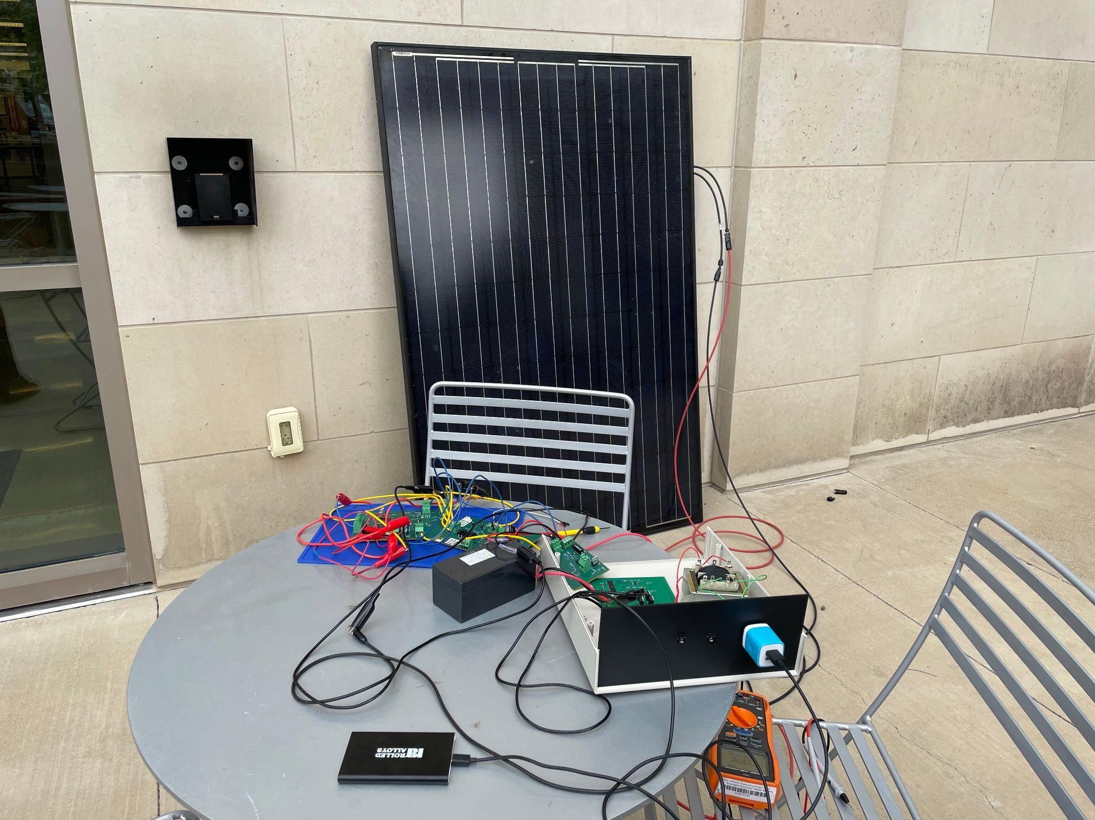

***Figure 3.1.*** *Full System*

***3.1 DC and AC Data***

The Solar/Battery Power System was able to run successfully with acceptable results. The DC-DC converter was designed to take in 20V-60V DC power from a solar panel and buck it down into a stable 12V output. The converter worked closely with the microcontroller to ensure a stable 12V output using an output voltage control signal ranging from 0V-1.2V. The DC-DC system was also designed to take an input of 5A while outputting 10A. It is important to note that this output current was only partially met as a single component on the DC-DC converter got extremely hot as output current was raised past 3A. The DC-AC inverter was designed to take in 12V DC via the DC-DC converter to output 115V AC, nearly identical to the U.S. electrical power grid. With the specifications of 12V DC and 1A, the inverter was only able to output around 108V AC and up to around 8W of power. There was power loss within the design, but AC power was ultimately able to be delivered at the output.

Multiple tests were performed and the data is recorded in the table below.

| **Full System Data** | |
| --- | --- |
| Solar Panel Voltage | 55V |
| Solar Panel Current | 1.2A |
| DC Output Voltage | 3A |
| DC Output Current | 11.7V |
| DC Output Power | 35.1W |
| AC Output Voltage | 108.78 V |
| AC Output Power | 8.104 W |
| AC Output Frequency | 60.156 Hz |
| ESP-32 Data Transfer | Every 2 Minutes |

***Table 3.1.1.*** *Full System Data*

***3.2 Sensor and Switch Data***

The sensor and switch worked closely with the other subsystems to automatically control the flow of power throughout the system. The sensor values are sent to the realtime database over 2 minute intervals. Additionally, the sensor values are sent to the microcontroller as soon as the signal can be sent with minimal delay. When the solar panel is no longer producing over 30V and no current is flowing through the current sensor, the system will switch to the battery control. In the event that the battery needs to be charged then the switch between the solar panel and battery is closed until the battery is fully charged. If not enough power is coming from the battery and the solar panel then the whole system is shut down. As long as the solar panel is supplying power the system regulates the voltage output using max power point tracking to increase the voltage when needed. A voltage from 0.1 - 1.2V is sent to the DC-DC Converter to determine how much to boost the output voltage. However, it is important to note that the switch between the dc-dc converter and ac inverter was not functioning properly during full system integration and there was not enough time to troubleshoot the problem.

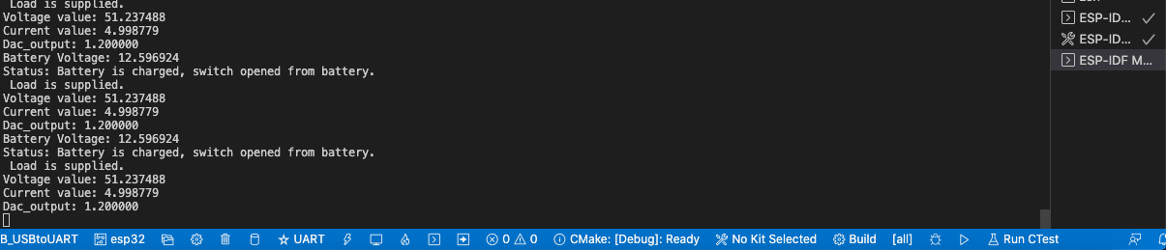

***Figure 3.2.1.*** *ESP-32 Terminal Output*

***3.3 Applications Data***

Both Android and Website applications worked closely with the ESP-32 on the microcontroller PCB. As shown above, the output of the battery and solar panel current and voltage were sent to the backend database which then fed the front-end user interface with information the user needs to maintain and diagnose their systems operation. In full integration, the most important aspect of the application system is getting data from the ESP-32. Without this data there is no use in having a website or android application. As shown in the subsystem section for the website and android application, this two-way communication was successful and satisfies “full integration” between the system and its application counterparts. The three pictures shown below represent this two-way communication.



***Figure 3.3.1.*** *ESP-32 Sending Data to Database*

**

***Figure 3.3.2.*** *Backend Database Receiving ESP-32 Information*



***Figure 3.3.3.*** *Front-End receiving Database information from ESP-32 Dynamically*

***4. Conclusion***

The final system performed fairly decently, although many changes could have been implemented to further improve the overall system performance. The system successfully outputs both AC and DC power and is capable of powering smaller electronic devices.

***4.1 Learnings***

The project provided a very valuable learning experience for every member of the group. Project and time management, teamwork, and technical electrical engineering skills were some of the many lessons learned throughout the construction of the entire project. Introduction and experience using Altium software was integral for the overall project and all of the group has learned Altium skills that may be extremely useful in our future lines of work. Additionally, this project taught members the importance of communication. Oftentimes, a team will discuss what the project is but will never come to an agreement of what the common goal is. Furthermore, once a common goal is agreed upon, time management was then the next agreement that needed to be settled. This class has supported these two claims by providing members with a hard deadline during the semesters as well as bi-weekly presentations providing accountability between members.

***4.2 Future work***

The Solar/Battery System successfully operates but there are many improvements that could be implemented to better enhance the product to become marketable to the public such as:

* AC system protection to increase safety to the overall system and user
* Email/text message notifications when the power of the system changes from solar panel to battery and vice versa
* DC-DC current rating increases further to supply even high wattage devices.
* More robust sensor conversions for the voltage and current sensors
* Secondary power supply or larger battery to increase time usage.
* Applications that needs better backend support so that information can be organized better
* Application that dynamically updates information if a user signs in without refreshing the page
* Provide scalability for the applications by providing a better database framework that can hold more data as well as better reaction times for updating data dynamically